|  |
| --- |
|  |
| Capstone Project Document |

**WingS**

Report #2 – Class Design

|  |  |  |
| --- | --- | --- |
| **WingS** | | |
| **Group Members** | Đào Trọng Nghĩa | SE03220 |
| Lê Hồng Nhiên | SE03377 |
| Tạ Ngọc Duy | SE03267 |
| Đỗ Văn Tuấn | SE03297 |
| Hoàng Anh Tuấn | SE03108 |
| **Supervisor** | Mr. Nguyễn Văn Sang | |
| **Project code** | WS | |

**- Hanoi, 10/2016 –**

# SIGNATURE PAGE

AUTHOR: Tạ Ngọc Duy 08/11/2016

Team member

REVIEWERS: Đào Trọng Nghĩa --/--/2016

Project manager

APPROVAL: Nguyễn Văn Sang --/--/2016

Supervisor

Record of change

*A - Added M - Modified D – Deleted

|  |  |  |  |  |  |
| --- | --- | --- | --- | --- | --- |
| Effective Date | Changed Item | A,M,D | Change Description | Reason for Change | Rev. Number |
| 08/Nov/2016 | Create Class Design | A | First version | Create Class Design | 1.0 |
|  |  |  |  |  |  |
|  |  |  |  |  |  |
|  |  |  |  |  |  |
|  |  |  |  |  |  |
|  |  |  |  |  |  |
|  |  |  |  |  |  |
|  |  |  |  |  |  |
|  |  |  |  |  |  |
|  |  |  |  |  |  |
|  |  |  |  |  |  |
|  |  |  |  |  |  |

TABLE CONTENTS

SIGNATURE PAGE 1

Introduction 3

1.1 Purpose 3

1.2 Definitions, Acronyms and Abbreviations 3

2 Package 3

2.1 Package Diagram 3

2.2 Package Description 4

2.2.1 Model 4

2.2.2 DTOs 10

2.2.3 View 10

2.2.4 Repository 11

2.2.5 Controller 14

3 Function 25

3.1 Common 25

3.1.1 Class diagram 25

3.1.2 Sequence diagram 25

3.2 Event management 28

3.2.1 Class diagram 28

3.2.2 Sequence diagram 29

3.3 Thread management 39

3.3.1 Class diagram 39

3.3.2 Sequence diagram 39

3.4 Organization management 41

3.4.1 Class diagram 41

3.4.2 Sequence diagram 42

3.5 User Management 43

3.5.1 Class diagram 43

3.5.2 Sequence diagram 44

3.6 Report Management 45

3.6.1 Class diagram 45

3.6.2 Sequence diagram 46

3.7 Like Management 48

3.7.1 Class diagram 48

3.7.2 Sequence diagram 48

3.8 Message Management 51

3.8.1 Class diagram 51

3.8.2 Sequence diagram 52

3.9 Comment Management 48

3.9.1 Class diagram 48

3.9.2 Sequence diagram 48

# Introduction

## Purpose

WingS class design document contains descriptions of all classes of the WingS. It includes: Class diagrams that describe the static relation of all classes in the system.

## Definitions, Acronyms and Abbreviations

|  |  |  |
| --- | --- | --- |
| Abbreviations | Description | Comment |
| WS | WingS |  |
| FAQ | Frequently Asked Question |  |

1. Definitions, Acronyms and Abbreviations

# Package

## Package Diagram

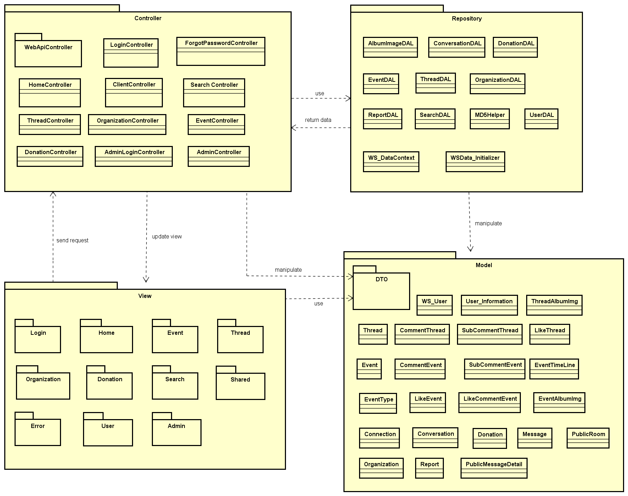

1. Package Diagram

## Package Description

### Model

#### WS_User

|  |  |  |  |  |  |
| --- | --- | --- | --- | --- | --- |
| No | Field Name | Type | Default | Note | Description |
|  | UserID | int |  | public | User’s ID |
|  | UserName | String |  | public | User’s name |
|  | UserPassword | String |  | public | User’s password |
|  | AccountType | bool |  | public | User’s account type (user, admin) |
|  | IsActive | bool |  | public | User’s status (active or inactive) |
|  | IsVerify | bool |  | public | User’s account verify status (yes or not) |
|  | CreatedDate | Datetime |  | public | User’s created date |
|  | LastLogin | Datetime? |  | public | User’s last login time |
|  | Email | string |  | public | User’ email verify status |
|  | VerifyCode | string |  | public | User’s verify account code |

1. WS_User model

#### User_Information

|  |  |  |  |  |  |
| --- | --- | --- | --- | --- | --- |
| No | Field Name | Type | Default | Note | Description |
|  | UserID | int |  | public | User’s ID |
|  | FullName | String |  | public | User’s full name |
|  | EFullName | String |  | public | User’s full name |
|  | ProfileImage | String |  | public | User’s profile image |
|  | UserAddress | String |  | public | User’s address |
|  | EUserAddress | String |  | public | User’s eaddress |
|  | PhoneNumber | String |  | public | User’s phone number |
|  | DoB | Datetime |  | public | User’s date of birth |
|  | Phone | String |  | public | User’s website |
|  | Gender | String |  | public | User’s gender |
|  | Country | String |  | public | User’s country |
|  | FacebookUrl | String |  | public | User’s facebook link |
|  | OrgnazationIDFollow | String |  | public | User’s OrgnazationIDFollow |
|  | UserSignature | String |  | public | User’s Signature |
|  | Point | Int |  | public | User’s point |

1. User_Information model

#### Event

|  |  |  |  |  |  |
| --- | --- | --- | --- | --- | --- |
| No | Field Name | Type | Default | Note | Description |
|  | EventID | int |  | public | Event’s ID |
|  | CreatorID | int |  | public | Event’s creator (userID) |
|  | EventType | int |  | public | Event’s type |
|  | EventName | String |  | public | Event’s name |
|  | Created_Date | Datetime |  | public | Event’s date created |
|  | Finish_Date | Datetime |  | public | Event’s finish date |
|  | Updated_Date | Datetime |  | public | Event’s update timeline |
|  | ShortDescription | String |  | public | Event’s shortDescription |
|  | Description | String |  | public | Event’s description |
|  | Location | String |  | public | Event’s location |
|  | VideoUrl | String |  | public | Event’s video URL |
|  | TotalPoint | int |  | public | Event’s TotalPoint |
|  | Status | bit |  | public | Event’s status |
|  | Views | int |  | public | Event’s total views |
|  | Likes | int |  | public | Event’s total likes |
|  | ExpectedMoney | decimal |  | public | Event’s expected money |
|  | IsOpen | bool |  | public | Event’s activity status |

1. Event model

#### Organization Model

|  |  |  |  |  |  |
| --- | --- | --- | --- | --- | --- |
| No | Field Name | Type | Default | Note | Description |
|  | OrganazationID | Int |  | public | Organization’s ID |
|  | OrganazationName | String |  | public | Organization’s Name |
|  | Introduction | String |  | public | Introduce about Organization |
|  | LogoUrl | String |  | public | Organization’s logo |
|  | Phone | String |  | public | Organization’s phone |
|  | Email | String |  | public | Organization’s email for contact |
|  | Address | String |  | public | Organization’s Address |
|  | Status | String |  | public | Organization’s Status |
|  | Point | int |  | public | Organization’s point |
|  | IsActive | bool |  | public | Organization’s activity status |
|  | IsVerify | bool |  | public | Organization’s creating request status |
|  | CreatedDate | DateTime |  | public | Organization’s created date |

1. Organization Model

#### Event Type model

|  |  |  |  |  |  |
| --- | --- | --- | --- | --- | --- |
| No | Field Name | Type | Default | Note | Description |
|  | EventTypeID | int |  | private | EventType’s ID |
|  | EventTypeName | String |  | private | EventType’s name |
|  | IsActive | bool |  | private | EventType’s active status |
|  | Content | String |  | private | EventType’s description |

1. Event Type Model

#### ReportEvent Model

|  |  |  |  |  |  |
| --- | --- | --- | --- | --- | --- |
| No | Field Name | Type | Default | Note | Description |
|  | ReportID | int |  | public | Report ’s ID |
|  | UserID | int |  | public | Report ’s user id, who report project |
|  | Reason | String |  | public | Report ’s Reason |
|  | ReportTime | datetime |  | public | Report ’s report date |
|  | Type | String |  | public | Report ’s type |
|  | ReportTo | int |  | public | Report ’s to whom |
|  | Status | String |  | public | Report’s status (new, viewed, done) |
|  | UpdatedTime | DateTime |  | public | Report ’s update time |

1. Report Model

#### Donation Model

|  |  |  |  |  |  |
| --- | --- | --- | --- | --- | --- |
| No | Field Name | Type | Default | Note | Description |
|  | DonationId | int |  | public | Donation’s ID |
|  | UserID | int |  | public | Back’s user id |
|  | EventId | int |  | public | Event’s project id |
|  | DonatedDate | Datetime |  | public | Donated’s date |
|  | IsPublic | bool |  | public | Is Back public |
|  | DonatedMoney | decimal |  | public | Amount money donate |
|  | TradeCode | string |  | public | Trade code |
|  | Content | string |  | public | Content of donate |

1. Donation Model

#### EventTimeLine Model

|  |  |  |  |  |  |
| --- | --- | --- | --- | --- | --- |
| No | Field Name | Type | Default | Note | Description |
|  | TimeLineId | int |  | public | Event’s schedule |
|  | EventId | int |  | public | EventID |
|  | Content | string |  | public | Event’s timeline content |
|  | FromDate | DateTime |  |  | Starting date |
|  | ToDate | DateTime |  |  | End date |
|  | Status | bool |  |  | Sub event’s status |

1. EventTimeLine Model

#### CommentEvent Model

|  |  |  |  |  |  |
| --- | --- | --- | --- | --- | --- |
| No | Field Name | Type | Default | Note | Description |
|  | CommentEventId | int |  | public | Comment’s ID |
|  | UserID | int |  | public | Comment’s user id |
|  | EventID | int |  | public | Comment’s Event id |
|  | CmtContent | String |  | public | Comment’s content |
|  | CmtDate | Datetime |  | public | Comment’s date |
|  | Status | bool | true | public | Comment’s status |

1. CommentEvent Model

#### SubcommentEvent Model

|  |  |  |  |  |  |
| --- | --- | --- | --- | --- | --- |
| No | Field Name | Type | Default | Note | Description |
|  | SubCommentEventId | int |  | public | SubCommentEvent’s ID |
|  | CommentEventId | int |  | public | CommentEvent’s ID |
|  | UserId | int |  | public | UserID who comment |
|  | Content | string | 0 | public | SubCommentEvent’s content |
|  | CommentDate | Datetime | 1 | public | SubCommentEvent’s date |
|  | Status | bool |  | public | SubCommentEvent’s status |

1. SubcommentEvent Model

#### LikeEvent Model

|  |  |  |  |  |  |
| --- | --- | --- | --- | --- | --- |
| No | Field Name | Type | Default | Note | Description |
|  | LikeId | int |  | public | Like’s ID |
|  | UserId | int |  | public | Like’s user id |
|  | EventId | int |  | public | Like’s event id |
|  | Status | bool |  | public | Like’s status |

1. LikeEvent Model

#### LikeCommentEvent Model

|  |  |  |  |  |  |
| --- | --- | --- | --- | --- | --- |
| No | Field Name | Type | Default | Note | Description |
|  | LikeCommentId | int |  | public | LikeComment’s ID |
|  | CommentId | int |  | public | LikeComment’s comment id |
|  | UserId | int |  | public | LikeComment’s user id |
|  | Status | bool |  | public | LikeComment’s status |

1. LikeCommentEvent Model

#### EventAlbumImage Model

|  |  |  |  |  |  |
| --- | --- | --- | --- | --- | --- |
| No | Field Name | Type | Default | Note | Description |
|  | ImageId | int |  | public | Image’s Id |
|  | EventId | int |  | public | Event’s ID |
|  | ImageUrl | String |  | public | Image URL link |
|  | Status | bool |  | public | Image’s status |

1. EventAlbumImage Model

#### Thread Model

|  |  |  |  |  |  |
| --- | --- | --- | --- | --- | --- |
| No | Field Name | Type | Default | Note | Description |
|  | ThreadId | int |  | public | Thread’s ID |
|  | UserId | Int |  | public | user id of user who create slide |
|  | Title | String |  | public | Thread’s title |
|  | [Content] | String |  | public | Thread’s content |
|  | ShortDescription | String |  | public | Thread’s short description |
|  | VideoUrl | String |  | public | Thread’s url link |
|  | CreatedDate | datetime | true | public | The date which thread has been created |
|  | UpdatedDate | datetime |  | public | Last update of thread |
|  | Status | bool |  | public | Thread’s status |

1. Thread table

#### CommentThread Model

|  |  |  |  |  |  |
| --- | --- | --- | --- | --- | --- |
| No | Field Name | Type | Default | Note | Description |
|  | CommentThreadId | int |  | public | CommentThread’s ID |
|  | UserID | int |  | public | Comment’s user id |
|  | ThreadID | int |  | public | Comment’s Thread id |
|  | CmtContent | String |  | public | Comment’s content |
|  | CmtDate | Datetime |  | public | Comment’s date |
|  | Status | bool | true | public | Comment’s status |

1. Comment Thread table

#### SubCommentThread Model

|  |  |  |  |  |  |
| --- | --- | --- | --- | --- | --- |
| No | Field Name | Type | Default | Note | Description |
|  | CommentThreadId | int |  | public | CommentThread’s ID |
|  | UserID | int |  | public | Comment’s user id |
|  | ThreadID | int |  | public | Comment’s Thread id |
|  | CmtContent | String |  | public | Comment’s content |
|  | CmtDate | Datetime |  | public | Comment’s date |
|  | Status | bool | true | public | Comment’s status |

1. Comment Thread table

#### LikeThread Model

|  |  |  |  |  |  |
| --- | --- | --- | --- | --- | --- |
| No | Field Name | Type | Default | Note | Description |
|  | LikeId | int |  | private | Like’s ID |
|  | UserId | int |  | private | Like’s user id |
|  | ThreadId | int |  | private | Like’s thread id |
|  | Status | String |  | private | Like’s status |

1. Like Thread Model

#### ThreadAlbumImage Model

|  |  |  |  |  |  |
| --- | --- | --- | --- | --- | --- |
| No | Field Name | Type | Default | Note | Description |
|  | ImageId | int |  | public | Image’s Id |
|  | ThreadId | int |  | public | Thread’s ID |
|  | ImageUrl | String |  | public | Image URL link |
|  | Status | bool |  | public | Image’s status |

1. ThreadAlbumImage Model

#### Connection Model

|  |  |  |  |  |  |
| --- | --- | --- | --- | --- | --- |
| No | Field Name | Type | Default | Note | Description |
|  | ConnectionId | int |  | public | Connection’s Id |
|  | UserId | int |  | public | User’s ID |
|  | ConnectionString | String |  | public | Connection string of each user when connect to WS system |

1. Connection Model

#### Conversation Model

|  |  |  |  |  |  |
| --- | --- | --- | --- | --- | --- |
| No | Field Name | Type | Default | Note | Description |
|  | ConversationID | int |  | public | Conversation’s ID |
|  | CreatorID | int |  | public | Conversation’s creator id |
|  | ReceiverID | int |  | public | Conversation’s receiver |
|  | Title | String |  | public | Conversation’s title |
|  | CreatedDate | Datetime |  | public | Conversation’s created date |
|  | UpdatedDate | Datetime |  | public | Conversation’s update date |
|  | isHidden | bool |  | public | Conversation’s showing status |
|  | isRead | bool |  | public | Conversation’s reading status |
|  | Status | bool |  | public | Conversation’s status |

1. Conversation Model

#### Message Model

|  |  |  |  |  |  |
| --- | --- | --- | --- | --- | --- |
| No | Field Name | Type | Default | Note | Description |
|  | MessageID | int |  | public | Message’s ID |
|  | ConversationID | int |  | public | Message’s conversation id |
|  | UserID | int |  | public | Message’s user id |
|  | CreatedDate | Datetime |  | public | Message’s sent time |
|  | Content | String |  | public | Message’s content |
|  | Status | bool |  | public | Message’s status |

1. Message Model
2. Conversation Model

#### PublicMessageDetail Model

|  |  |  |  |  |  |
| --- | --- | --- | --- | --- | --- |
| No | Field Name | Type | Default | Note | Description |
|  | Id | int |  | public | PublicMessage’s ID |
|  | UserId | int |  | public | UserID who send message |
|  | EventId | int |  | public | Event id which contain message |
|  | Message | String |  | public | Message’s content |
|  | CreatedDate | Datetime |  | public | Message’s sent time |
|  | Status | bool |  | public | Message’s status |

1. Public Message Detail Model

#### PublicRoom Model

|  |  |  |  |  |  |
| --- | --- | --- | --- | --- | --- |
| No | Field Name | Type | Default | Note | Description |
|  | PublicRoomId | int |  | public | PublicMessage’s ID |
|  | ConnectionId | int |  | public | Connection ID of room chat |
|  | EventId | int |  | public | Event’s id which contain room chat |

1. Public Room Model

### DTOs

Contain many data transfer object classes.

### View

Contain many .cshtml files to display user interface.

### DataAcess

#### UserDAL

|  |  |  |  |  |
| --- | --- | --- | --- | --- |
| No | Method | Parameter | Return | Description |
|  | AddNewUser | WS_User | GetUserByUserNameOrEmail | Add new user to database |
|  | CountTotalUser |  | string | Count number of user |
|  | CountTotalEvent |  | string | Count number of event |
|  | CountTotalThread |  | string | Count number of thread |
|  | GetAllUser |  | listUser | Get all user by list |
|  | GetFullInforOfUserAsBasicUser | int | currentUser | Get all basic information of user account by user ID |
|  | GetByUserNameOrEmail | string, string | WS_User | Get user by username, email and password |
|  | GetByUserNameOrEmail | string | WS_User | Get user by username or email |
| 9 | GetNewUser |  | List<Ws_User> | get the new user who recently registered |
| 10 | GetTopNumberRankingUser | int | List<UserBasicInfoDTO> | Get list top users who have highest point |
| 11 | GetTopNumberThreadCreator | int | List<UserBasicInfoDTO> | Get list top threads which have highest point |
| 12 | GetUserInformation | int | User_Information() | Get the user information |
| 13 | RegisterFacebook | dynamic | WS_User | Register new user from facebook information |
| 14 | UpdateUser | WS_User | WS_User | Update information of a user |

1. UserDAL

#### AlbumImageDAL

|  |  |  |  |  |
| --- | --- | --- | --- | --- |
| No | Method | Parameter | Return | Description |
|  | AddEventAlbum | EventAlbumImageDTO | string | Add new event album |
|  | AddNewAlbum | ThreadAlbumImageDTO | string | Add new thread album |
|  | CreateEmptyEventAlbum |  | string | Create empty event album |
|  | CreateEmptyThreadAlbum |  | string | Create empty thread album |

1. AlbumImageDAL

#### EventDAL

|  |  |  |  |  |
| --- | --- | --- | --- | --- |
| No | Method | Parameter | Return | Description |
|  | AddNewEvent | string, string, string |  | Create a project report function |
|  | AddNewEventTimeLine | string, string, string |  | Create a user report function |
|  | AddNewComment |  | List<ReportProjectDTO> | Get list project report |
|  | AddNewSubComment | int, string |  | Change status of a project report |
|  | ChangelikeState | int, string | Bool | Change status of a user report |
|  | ChangelikeStateForComment | Int, string | Bool | Check like status of comment |
|  | CheckUserIsLikedOrNot | Int, string | Bool | Check user liked or not |
|  | CountCommentInEvent | int | int | Count total comments in event |
|  | CountDonatedUserOfEvent | int | int | Count number user donated in event |
|  | UpdateEvent | String | GetEventTypeById | Update event |
|  | CountLikeInCommentEvent | int | int | Count number like in a comment |
|  | CountNumberEventRelateAnEventType | int | int | Count number event relate an event type to group by |
|  | CreateEmptyEvent |  | eventInfo | Crate an empty event |
|  | CreateEventType |  | string | Create an event type |
|  | CreateEmptyEventTimeLine |  | eventInfo | Create an empty event timeline |
|  | DeleteComment | Int, string | bool | Delete a comment |
|  | DeleteSubComment | Int, string | Bool | Delete a sub comment |
|  | GetAllCommentIdAndSubCommentId |  | List | Get all comment and sub comment |
|  | GetAllCommentInEvent | Int, string | List | Get all comment in event |
|  | GetAllEvents |  | List | Get all events |
|  | GetAllEventType |  | List | Get all event type |
|  | GetAllImageEventById | int | List | Get all image event by id of event |
|  | GetAllPublicMessage | int | List | Get all public message in chat room |
|  | GetAllSubCommentInEvent |  | List | Get all sub comment in event |
|  | GetDonatorInEvent | Int | List | Get donors list |
|  | GetEventBasicInfoById | Int | EventBasicInfo | Get event basic information |
|  | GetEventById | int | string | Get an event |
|  | GetEventNameById | int | string | Get event name by event id |
|  | GetEventsBelongToCreator | int | List | Get event’s creator |
|  | GetEventsBelongToCreatorByPoint | Int | List | Get event belong to creator by point |
|  | GetEventsBelongToCreatorByStatus | Int,  bool | List | Get event belong to creator by status |
|  | GetEventSortByPoint |  | List<Event> | Get event list and Sort event by point |
|  | GetEventSortByNumberOfDonator |  | List<Event> | Get event list and Sort event by donors |
|  | GetEventTimeLineByEventId | int | String | Get event time line |
|  | GetEventType |  | EventTypeDropList | Get event types |
|  | GetEventTypeById | int | EventType | Get event types |
|  | GetEventTypeInfomation |  | EventBasicInfo | Get event type’s information |
|  | GetFullEventBasicInformation | int |  | Get full event basic information |
|  | GetMainImageEventById | int | EventAlbumImage | Get Main Image Event By Id |
|  | GetNewestEventByCreatedDate |  | List<Event> | Get Newest Event By Created Date |
|  | GetOrganizationById | Int | String | Get Organization By Id |
|  | GetSubCommentInEventById | Int,  String | List<BasicCommentThread> | Get Sub Comment In Event By Id |
|  | GetTopEventSortByMoneyDonateIn | int | List<EventBasicInfo> | Get Top Event Sort By Money Donate In |
|  | GetTopFourEventByPoint | int | List<EventBasicInfo> | Get Top Four Event By Point |
|  | GetTopNewEvent |  | List<EventBasicInfo> | Get Top New Event |
|  | GetTopOneEventOfOrganization | int | List<Event> | Get Top One Event Of Organization |
|  | GetTotalRaisedMoneyOfEvent | int | decimal | Get Total Raised Money Of Event |

1. EventDAL

#### ThreadDAL

|  |  |  |  |  |
| --- | --- | --- | --- | --- |
| No | Method | Parameter | Return | Description |
|  | AddNewComment | CommentThread |  | Add new comment in thread |
|  | SubCommentThread | string string |  | Get sub comment thread |
|  | AddNewThread | CreateThreadInfo, string | GetThreadById | Add new thread |
|  | ChangelikeState | int, string |  | Change like status |
|  | CheckUserIsLikedOrNot | int, string |  | Check user liked or not |
|  | CountCommentInThread | int, | int | Count number comment in thread |
|  | CountLikeInThread | int | int | Count like in thread |
|  | CountNewThread |  | int | Count new thread |
|  | CountThreadIsBan |  | int | Count thread banned |
|  | CountTotalThread |  | int | Count all thread |
|  | CreateEmptyThread |  |  | Create an empty thread |
|  | GetAllCommentIdAndSubCommentId |  | list | Get all comment and sub comment in thread |
|  | GetAllCommentInThread | int | list | Get all comment in thread |
|  | GetAllImageThreadById | Int | list | Get all image thread |
|  | GetAllSubCommentInThread |  | list | Get all sub comment |
|  | GetAllThread |  | list | Get all thread |
|  | GetFullThreadBasicInformation | Int | ThreadBasicInfo | Get full thread information |
|  | GetMainImageThreadById | Int | ThreadAlbumImage | Get main image thread |
|  | GetNewestNumberThread | Int | list | Get newest number thread |
|  | GetNewestThreadByCreatedDate |  | List | Get newest thread by created date |
|  | GetNewThread |  | List | Get new thread by created date |
|  | GetNumberOfPostPerUser | Int | Int | Get number thread of user |
|  | GetSubCommentInThreadById | Int | List | Get sub comment of thread |
|  | GetThreadById | Int |  | Get thread information |
|  | GetThreadsOfUser | Int | List | Get thread by user owned |
|  | GetTopLikeNumberThread | Int | List | Get top like thread |
|  | GetTopThreadByCreatedDate | Int | List | Get top thread by created date |
|  | UpdateThread | thread | thread | Update thread |

1. ThreadDAL

#### OrganizationDAL

|  |  |  |  |  |
| --- | --- | --- | --- | --- |
| No | Method | Parameter | Return | Description |
|  | AddNewOrganization | CreateOrganization,  string | GetOrganizationById | Add new organization |
|  | CountOrganizationActiveOrNot | bool | int | Count Organization by active or inactive |
|  | CountOrganizationVerifyOrNot | Bool | int | Count number of organization by verify |
|  | CountTotalOrganization |  | int | Count total number of organization |
|  | CreatEmptyOrganization |  | Organizations | Create an empty organization |
|  | EditOrganization | organizationBasic, string | bool | Edit organization |
|  | GetAllOrganization |  | List | Get all organization |
|  | GetFullOrganizationBasicInformation | Int | OrganizationBasic | Get all organization information |
|  | GetNewestCreatedOrgzation |  | List | New list new created organization |
|  | GetOrganizationById | Int |  | Get organization by ID |
|  | GetOrganizationOrderByDecendingPoint |  | List | List organization order by descending point |
|  | GetStatisticAboutOrgaization |  | StatisticManageBasicInforDTO | Get statistic about organization |
|  | GetTopOrganization | Int | List | Get the top organizations |
|  | GetTopThreeOrganizations | int | List | Get the 3 top organizations |
|  | UpdateOrganization | Organization | Organization | Update organization |

1. OrganizationDAL

#### DonationDAL

|  |  |  |  |  |
| --- | --- | --- | --- | --- |
| No | Method | Parameter | Return | Description |
|  | AddNewDonation | DonationDTO | bool | Add new donation |
|  | GetFullInformationOfDonation | Int | DonationDTO | Get full information of donations |
|  | GetLastDonateInformation | Int | Donation | Get the information of last donation |
|  | GetNumberEventDonatedInByUsingUserId | int | Int | Get the number event donated by an user |
|  | GetTopNumberDonator | int | List | The list top donors |
|  | GetTopRecentlyDonator | int, | List<DonationDTO> | Get top recently donors |
|  | GetTotalMoneyDonatedInByUsingUserId | int | decimal | List total money donated by an user |

1. DonationDAL

#### SearchDAL

|  |  |  |  |  |
| --- | --- | --- | --- | --- |
| No | Method | Parameter | Return | Description |
|  | GetAllImageThreadById | Int | List<ThreadAlbumImage> | List all image of a thread |
|  | GetMainImageEventById | int | EventAlbumImage | Get avatar of thread |
|  | GetUserInfoById | Int,  string |  | Get user information |
|  | GetUserNameById | int | string | Get user name by user ID |
|  | SearchEvent | string | List<Event> | Search event |
|  | SearchOrganizations | string | List<Organization> | Search Organization |
|  | SearchThreads | string | List<Thread> | Search Thread |
|  | SearchUserInfo | string | List<User_Information> | Search User information |
|  | SearchUsers | string | List<Ws_User> | Search User account |

1. SearchDAL

#### ConversationDAL

|  |  |  |  |  |
| --- | --- | --- | --- | --- |
| No | Method | Parameter | Return | Description |
|  | AddNewConversation | Conversation | Conversation | Add a new conversation |
|  | AddNewMessage | Message | Message | Add new message in conversation |
|  | GetAllConservationByUserId | string | List<ConservationBasicInfoDTO> | List all conversation of an user |
|  | GetAllMessageByConservationId | int | List<MessageBasicInfoDTO> | List all message of conversation |
|  | GetConservationById | int | Conversation | Get conversation |
|  | UpdateTime | Conversation |  | Update time |

1. ConversationDAL

#### ReportDAl

|  |  |  |  |  |
| --- | --- | --- | --- | --- |
| No | Method | Parameter | Return | Description |
|  | AddNewReport | Report | Report | Add new report |
|  | CheckCurrentUserReportedOrNot | String, int, string | bool | Check current user has been reported or not |

1. ReportDAL

#### MD5Helper

|  |  |  |  |  |
| --- | --- | --- | --- | --- |
| No | Method | Parameter | Return | Description |
|  | MD5Encrypt | string | string | Encrypt password string to md5 string |

1. MD5Helper

### Controller

#### LoginController

|  |  |  |  |  |
| --- | --- | --- | --- | --- |
| No | Method | Parameter | Return | Description |
|  | AuthenFacebook |  | ActionResult | Use to request login to Facebook |
|  | FacebookCallback | string | ActionResult | Function callback, get data from Facebook |
|  | ChangePass | String, string | ActionResult | Encrypt user password to MD5 string and save to database |
|  | Login | LoginInfoDTO | ActionResult | Login user to WS system |
|  | ValidateUser | String, String, bool | ActionResult | Receive request login with form data included user name, password and account type. |
|  | Logout |  | ActionResult | Logout current user from WS. |
|  | CheckExistedUserNameOrEmail | String, string | ActionResult | Receive user account information and check if existence. |
|  | CheckVerifyCode | Object, string | ActionResult | Receive user account information and check if verify. |
|  | Register | UserRegisterDTO | ActionResult | Receive user information register request. |
|  | Active | string, string | ActionResult | Verify email account, active new account with code. |

1. Login Controller

#### HomeController

|  |  |  |  |  |
| --- | --- | --- | --- | --- |
| No | Method | Parameter | Return | Description |
|  | Index |  | ActionResult | Display main page of WS client. |
|  | AdminIndex |  | ActionResult | Display main page of WS admin. |
|  | Error |  | ActionResult | Display error page |

1. Home Controller

#### ClientController

|  |  |  |  |  |
| --- | --- | --- | --- | --- |
| No | Method | Parameter | Return | Description |
|  | Home |  | ActionResult | Display home page |
|  | Register |  | ActionResult | Display Register page |
|  | RegisterSuccess |  | ActionResult | Display register successful page |
|  | ForgotPassword |  | ActionResult | Display ForgotPassword page |
|  | Message |  | ActionResult | Display message list page |
|  | Profile |  | ActionResult | Display Profile page |
|  | Search |  | ActionResult | Display Search page |
|  | Login |  | ActionResult | Display login page |
|  | Discussion |  | ActionResult | Display Discussion page |
|  | ThreadDetail |  | ActionResult | Display Thread Detail page |
|  | CreateDiscussion |  | ActionResult | Display Create Discussion page |
|  | Event |  | ActionResult | Display Event page |
|  | CreateEvent |  | ActionResult | Display Create Event page |
|  | EventDetail |  | ActionResult | Display Event Detail page |
|  | Organization |  | ActionResult | Display Organization page |
|  | OrganizationDetail |  | ActionResult | Display Organization Detail page |
|  | CreateOrganization |  | ActionResult | Display Create Organization page |
|  | EditOrganization |  | ActionResult | Display Edit Organization page |
|  | Donate |  | ActionResult | Display Donation page |
|  | DonationComplete |  | ActionResult | Display donation successful page |
|  | Error |  | ActionResult | Display error page |
|  | VerifyAccount |  | ActionResult | Display verify account page when user finish sign-up their account. |

1. ClientController

#### AdminController

|  |  |  |  |  |
| --- | --- | --- | --- | --- |
| No | Method | Parameter | Return | Description |
|  | Dashboard |  | ActionResult | Display dashboard page. |
|  | AdminLogin |  | ActionResult | Display Project Dashboard page |
|  | UserDashBoard |  | ActionResult | Display Project List page |
|  | UserList |  | ActionResult | Display project detail page |
|  | UserProfile |  | ActionResult | Display slide page. |
|  | ThreadDashBoard |  | ActionRes | Display message list for admin. |
|  | ThreadList |  |  | Display message detail for admin. |
|  | ThreadDetail |  | ActionResult | Display User Dashboard project page |
|  | EventDashBoard |  | ActionResult | Display User List page |
|  | EventList |  | ActionResult | Display profile of a user page |
|  | EventType |  |  | Display backing list page. |
|  | EventDetail |  |  | Display category page. |
|  | OrganizationDashBoard |  |  | Display report user page. |
|  | OrganizationList |  |  | Display report project page |
|  | RegisterOrganization |  | ActionResult | Display Error page. |
|  | OrganizationDetail |  | ActionResult | Display 404 not found page. |
|  | DonationInfo |  |  |  |
|  | ReportUser |  |  |  |
|  | ReportUserDetail |  |  |  |
|  | ReportOrganization |  |  |  |
|  | ReportEvent |  |  |  |
|  | ReportThread |  |  |  |
|  | Index |  |  |  |

1. AdminPartialController

#### ForgotPasswordController

|  |  |  |  |  |
| --- | --- | --- | --- | --- |
| No | Method | Parameter | Return | Description |
|  | ValidateUser | string | ActionResult | Receive user data and validate. |
|  | Index | string | ActionResult | Reset password to random string for a user and send to user’s email. |

Table 2-21: User ForgotPassword Controller

#### DonationController

|  |  |  |  |  |
| --- | --- | --- | --- | --- |
| No | Method | Parameter | Return | Description |
|  | CheckOutNganLuong | Object | ActionResult | Get data from form and set to nganluongAPI |

Table 2-22: Donation Controller

#### EventPageController

|  |  |  |  |  |
| --- | --- | --- | --- | --- |
| No | Method | Parameter | Return | Description |
|  | CreateEvent | Object,  Object | ActionResult | Receive creating information of event |

Table 2-22: EventController

#### ThreadController

|  |  |  |  |  |
| --- | --- | --- | --- | --- |
| No | Method | Parameter | Return | Description |
|  | CreateDiscussion | Object, Object | ActionResult | Receive creating data of thread |

Table 2-22: Thread Controller

#### OrganizationController

|  |  |  |  |  |
| --- | --- | --- | --- | --- |
| No | Method | Parameter | Return | Description |
|  | CreateOrganization | Object, Object | ActionResult | Receive creating data of organization |
|  | EditOrganization | Object, Object | ActionResult | Receive update data of organization |

Table 2-22: Organization Controller

#### SearchController

|  |  |  |  |  |
| --- | --- | --- | --- | --- |
| No | Method | Parameter | Return | Description |
|  | Index |  | ActionResult | Display searching page |
|  | SearchResult | String,  string | ActionResult | Display search result below searching page |

Table 2-22: Search Controller

#### WebApiController

##### UserController

|  |  |  |  |  |
| --- | --- | --- | --- | --- |
| No | Method | Parameter | Return | Description |
|  | CheckLoginStatus |  | IHttpActionResult | Check status login of user |
|  | GetCreatedThreadOfUser | string | IHttpActionResult | Get list thread created of current user |
|  | GetCurrentUser | string | IHttpActionResult | Get current user. |
|  | GetCurrentUserId |  | IHttpActionResult | Get current user id. |
|  | GeUsertDonationInformation | string | IHttpActionResult | Get information of user who donate |
|  | UpdateUserInfo | Object | IHttpActionResult | Update user information |

Table 2-23: UserController Controller

##### ThreadController

|  |  |  |  |  |
| --- | --- | --- | --- | --- |
| No | Method | Parameter | Return | Description |
|  | AddComment | Object | IHttpActionResult | Add a comment to thread |
|  | AddSubComment |  | IHttpActionResult | Add a sub comment to thread |
|  | ChangeLikeState | int | IHttpActionResult | Change like status of thread |
|  | ChangeLikeStateForComment | int | IHttpActionResult | Change like status of comment |
|  | CheckCurrentUserIsLikedOrNot | int | IHttpActionResult | Check current like status of user |
|  | CheckExistedSubCommentOrNot | int | IHttpActionResult | Check current like status of sub comment |
|  | CountLikeInCommentThread | int | IHttpActionResult | Count number like of a comment |
|  | CountLikeInThread |  | IHttpActionResult | Count number like of a thread |
|  | DeleteComment |  | IHttpActionResult | Delete comment |
|  | DeleteSubComment |  | IHttpActionResult | Delete sub comment |
|  | GetAllComment |  | IHttpActionResult | List all comment in thread |
|  | GetAllSubComment |  | IHttpActionResult | List all sub comment in thread |
|  | GetNewestThread |  | IHttpActionResult | List all newest thread |
|  | GetSubCommentByCommentId |  | IHttpActionResult | List all sub comment by ID |
|  | GetThreadById |  | IHttpActionResult | List all thread by same creator |
|  | GetTopThreadByCreatedDate |  | IHttpActionResult | List top thread order by created date |

Table 2-23: Thread Controller

##### EventController

|  |  |  |  |  |
| --- | --- | --- | --- | --- |
| No | Method | Parameter | Return | Description |
|  | AddComment | Object | IHttpActionResult | Add a comment to thread |
|  | AddSubComment |  | IHttpActionResult | Add a sub comment to thread |
|  | ChangeLikeState | int | IHttpActionResult | Change like status of thread |
|  | ChangeLikeStateForComment | int | IHttpActionResult | Change like status of comment |
|  | CheckCurrentUserIsLikedOrNot | int | IHttpActionResult | Check current like status of user |
|  | CheckExistedSubCommentOrNot | int | IHttpActionResult | Check current like status of sub comment |
|  | CountLikeInCommentEvent | int | IHttpActionResult | Count number like of a comment |
|  | CountLikeInEvent |  | IHttpActionResult | Count number like of a event |
|  | DeleteComment |  | IHttpActionResult | Delete comment |
|  | DeleteSubComment |  | IHttpActionResult | Delete sub comment |
|  | GetAllComment |  | IHttpActionResult | List all comment in event |
|  | GetAllSubComment |  | IHttpActionResult | List all sub comment in event |
|  | GetNewestEvent |  | IHttpActionResult | List all newest thread |
|  | GetSubCommentByCommentId |  | IHttpActionResult | List all sub comment by ID |
|  | GetEventById |  | IHttpActionResult | List all thread by same creator |
|  | GetTopEventByCreatedDate |  | IHttpActionResult | List top thread order by created date |
|  | GetpublicMessage | Int | IHttpActionResult | Get message in chat room |
|  | GetDonatorInEvent | int | IHttpActionResult | Get donor of event |
|  | OrderEventListOfOrganizationByPoint | int | IHttpActionResult | List event order by organization’s point |
|  | OrderEventListOfOrganizationByStatus | Int, bool | IHttpActionResult | List event order by organization status |

Table 2-25: Event Controller

##### OrganizationController

|  |  |  |  |  |
| --- | --- | --- | --- | --- |
| No | Method | Parameter | Return | Description |
|  | GetAllOrganization |  | IHttpActionResult | List all organization |
|  | GetAllOrganizationWaitForAccept |  | IHttpActionResult | List all organizations waiting for accept |
|  | GetOrganizationSortByPoint |  | IHttpActionResult | List all organization order by activity point |
|  | GetOrganizationUsingId |  | IHttpActionResult | List organization by ID |
|  | GetRankOfOrganization |  | IHttpActionResult | List rank of organization |
|  | GetTopThreeOrganization |  |  | List top 3 organizations |

Table 2-24: Organization Controller

##### ReportApiController

|  |  |  |  |  |
| --- | --- | --- | --- | --- |
| No | Method | Parameter | Return | Description |
|  | CheckCurrentUserReportedOrNot | String, string | IHttpActionResult | Check current user reported or not |
|  | GetReportContentForOrg |  | IHttpActionResult | Get report content for organization |
|  | GetReportContentForUser |  | IHttpActionResult | Get report content for User |
|  | ReportOrg | String, int | IHttpActionResult | Report organization |
|  | ReportUser | String, string | IHttpActionResult | Report user |

Table 2-24: Report Controller

# Function

## Common

### Class Diagram

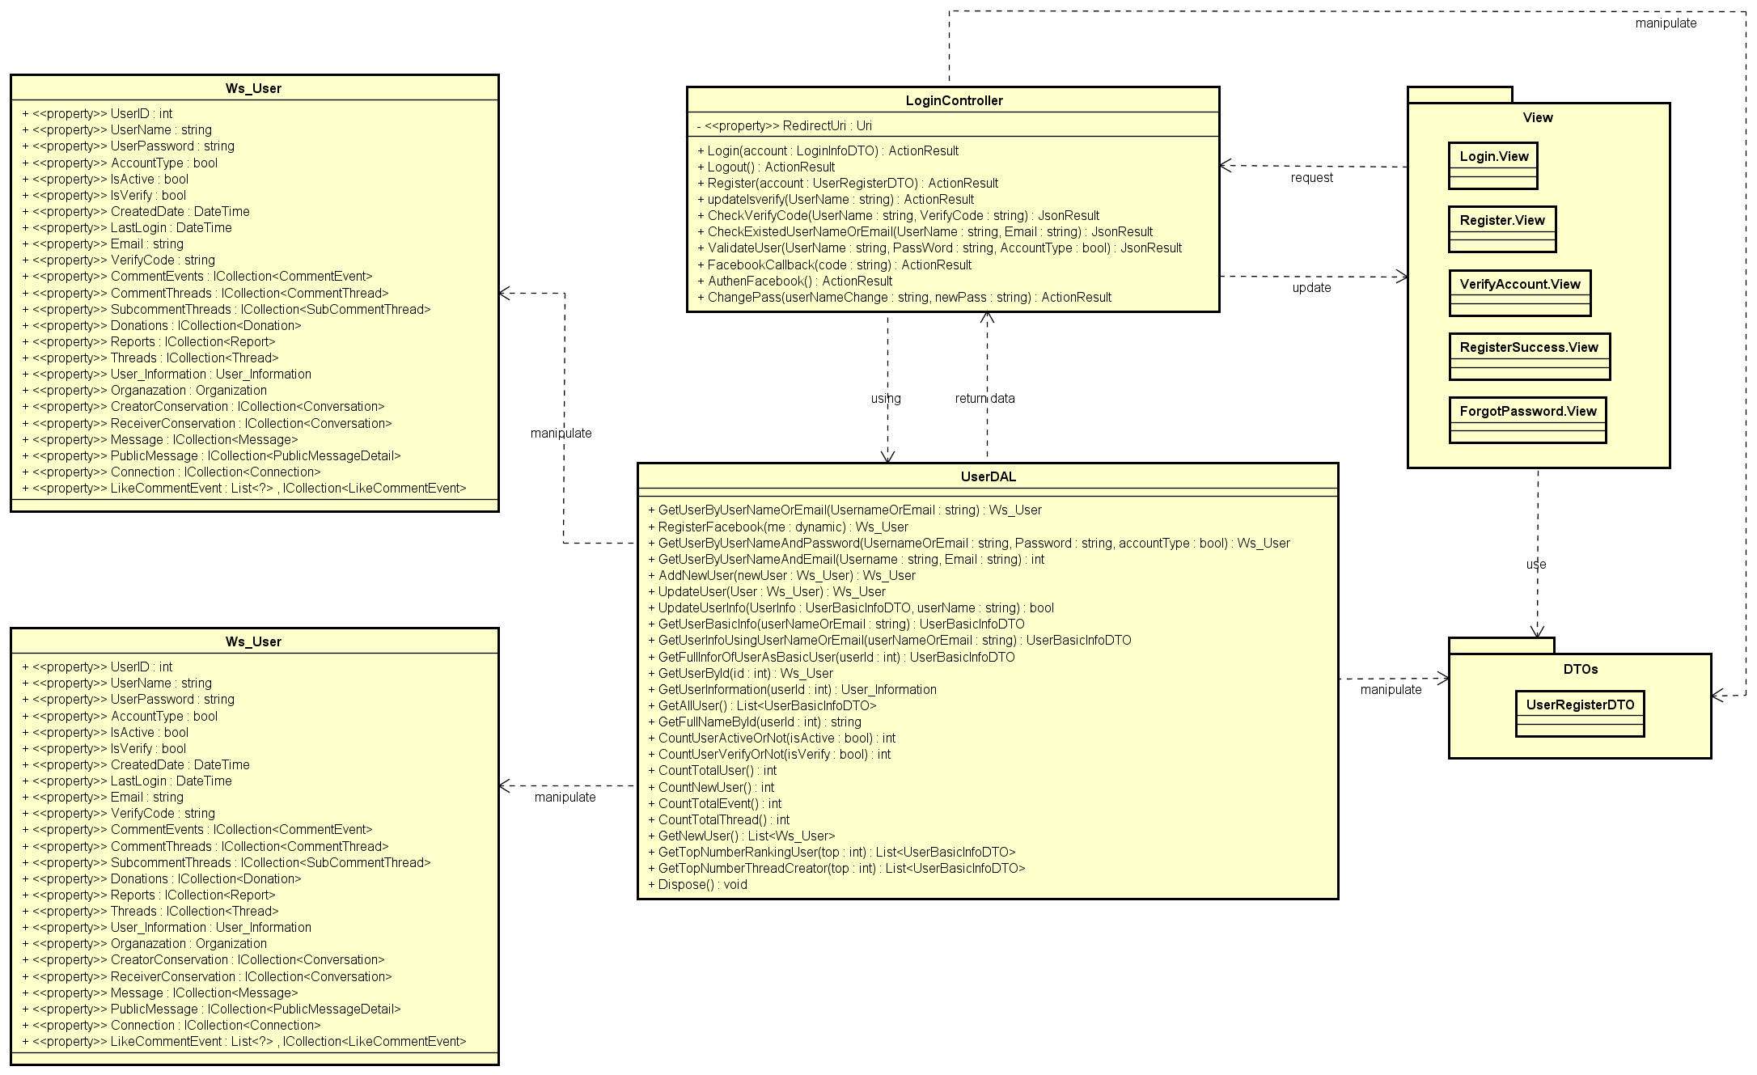

1. Common functions class diagram

### Sequence diagram

#### Login

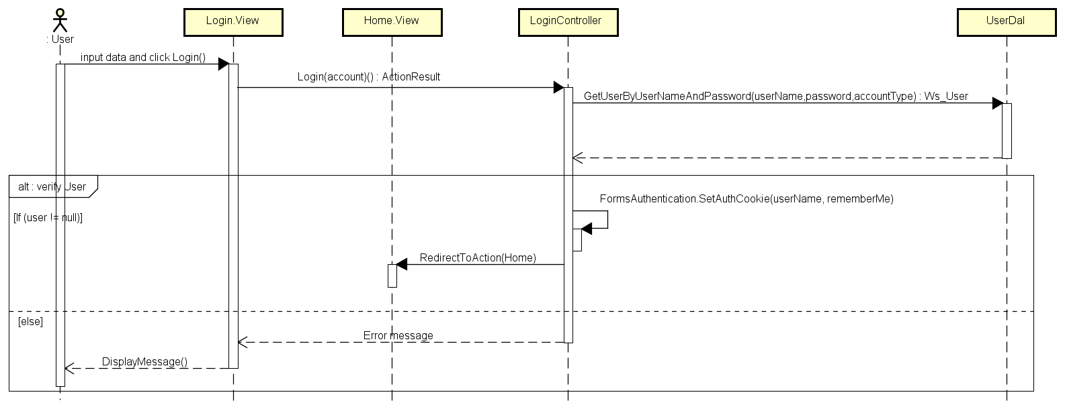

1. Login sequence diagram

#### Logout

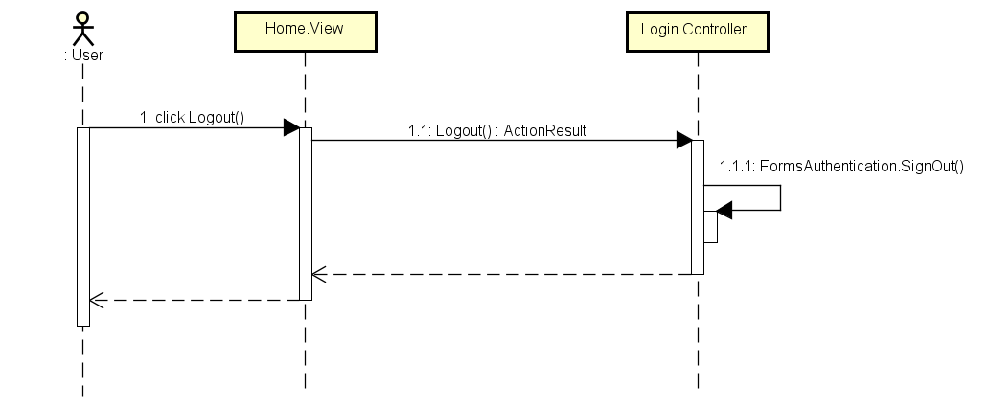

1. Logout sequence diagram

#### Register

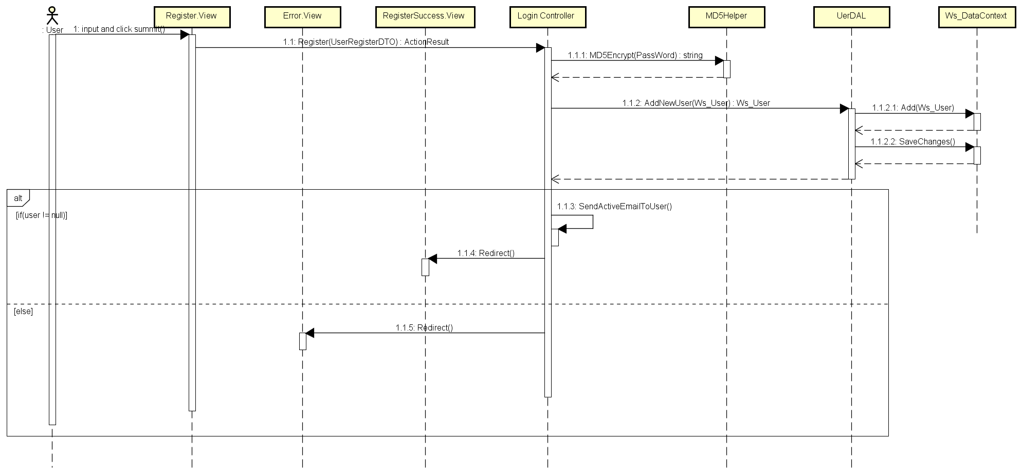

1. Register sequence diagram

#### Forgot Password

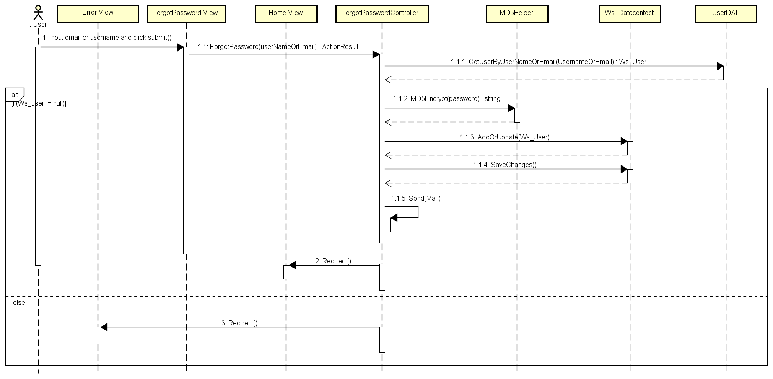

1. Forgot password sequence diagram

## Event management

### Class diagram

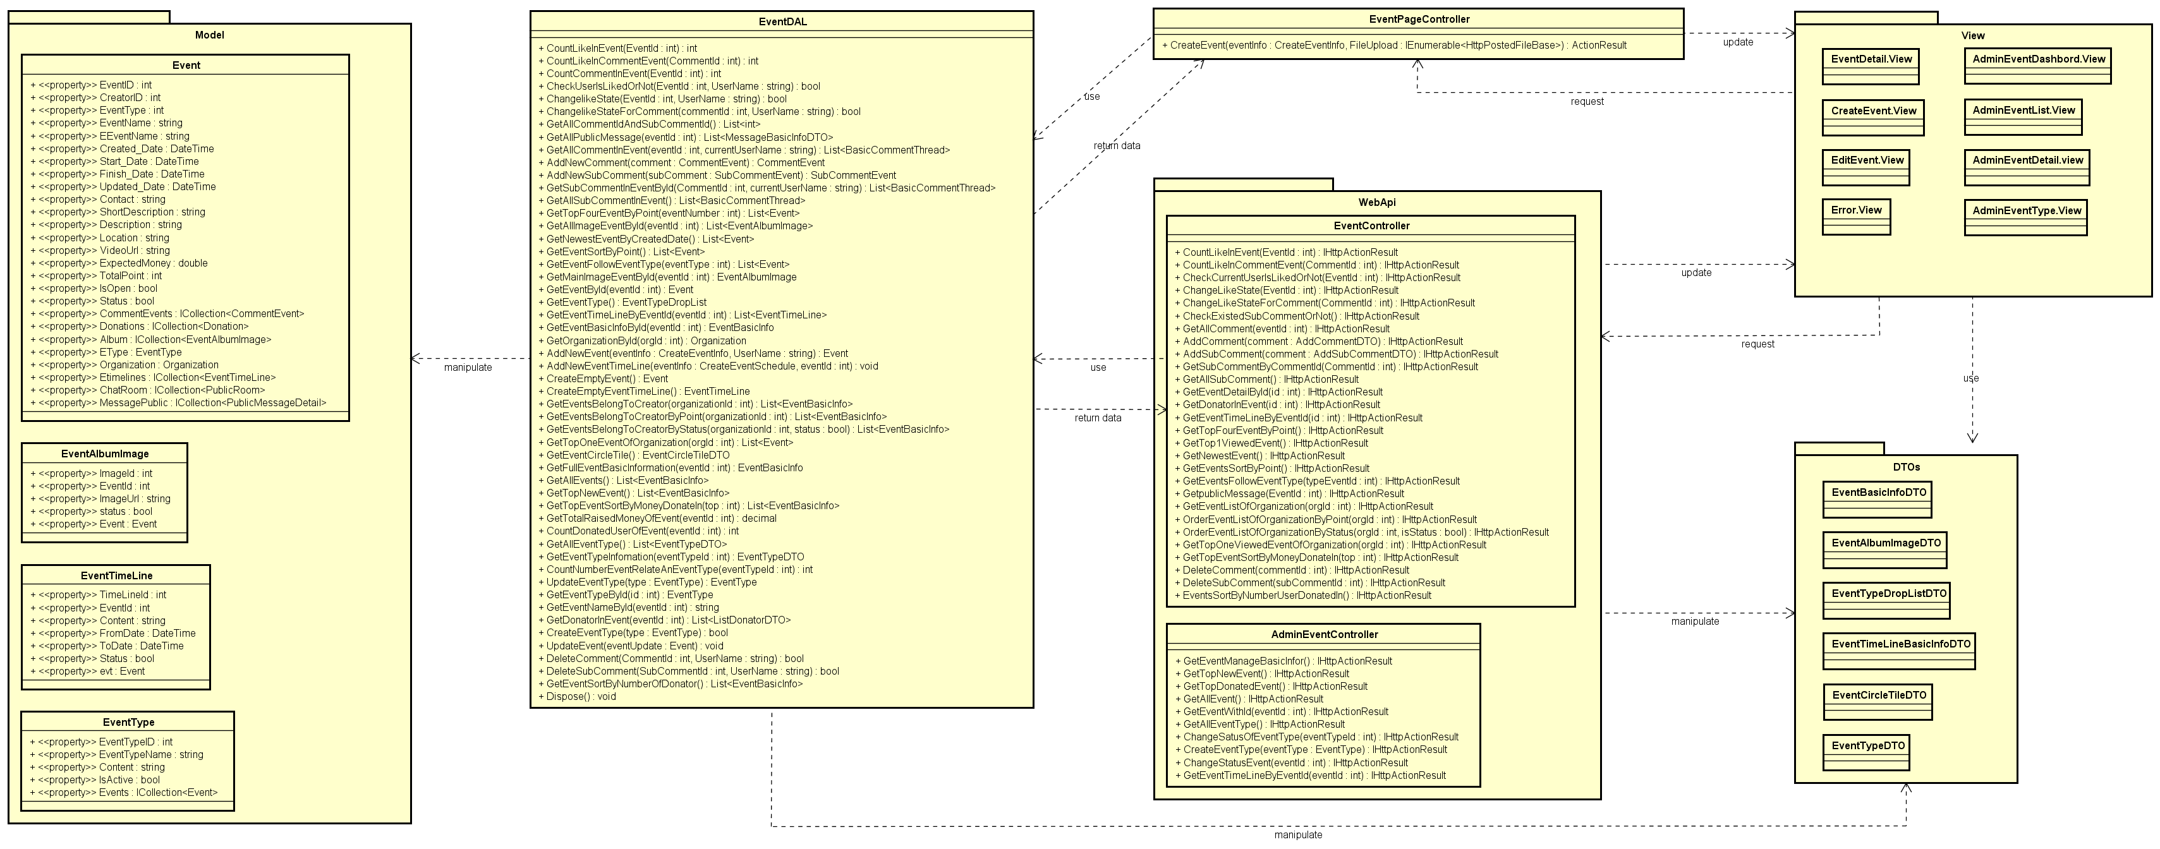

1. Event Management Class Diagram

### Sequence diagram

#### Create event

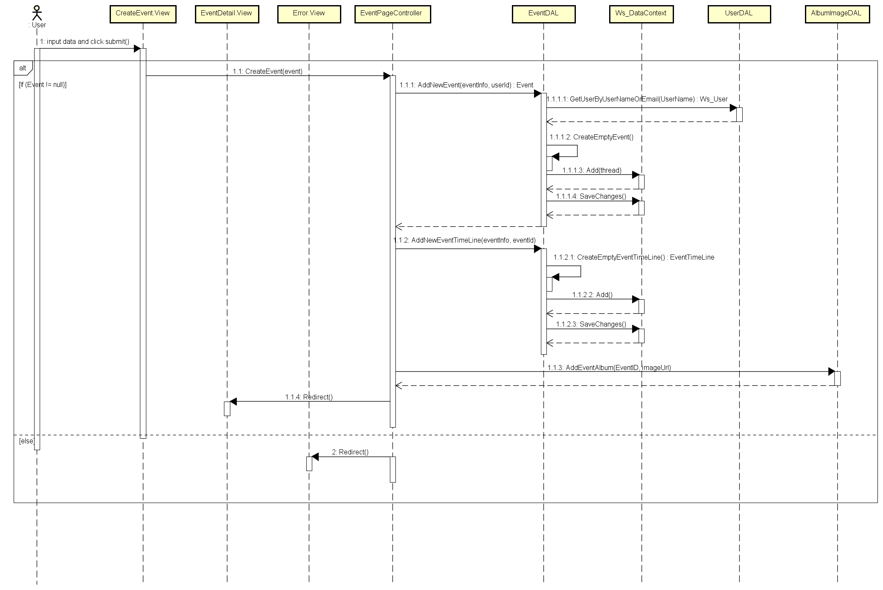

1. Create Event Sequence Diagram

## Thread management

### Class diagram

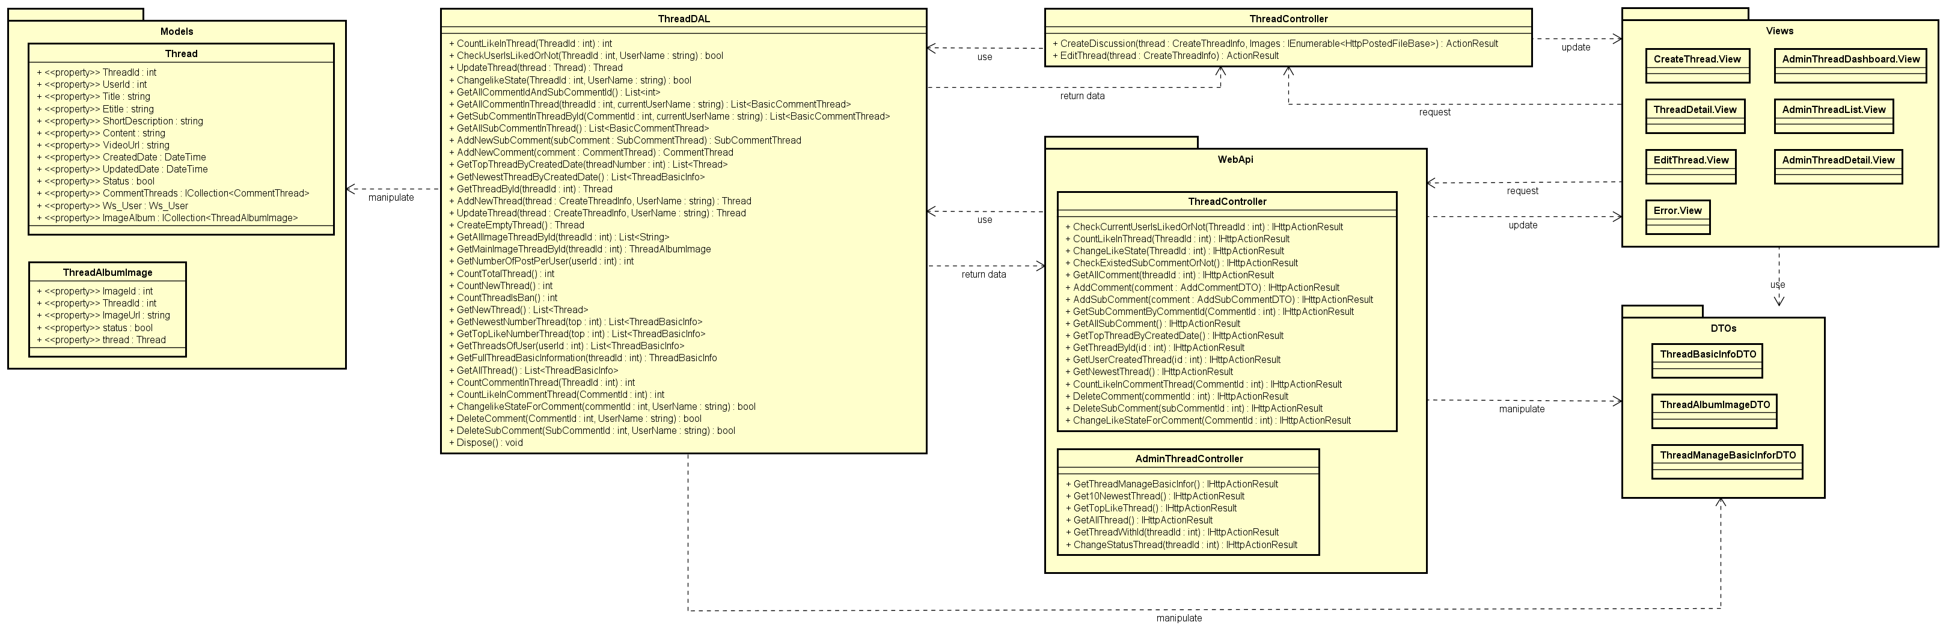

1. Thread Management Sequence Diagram

### Sequence diagram

#### Create thread

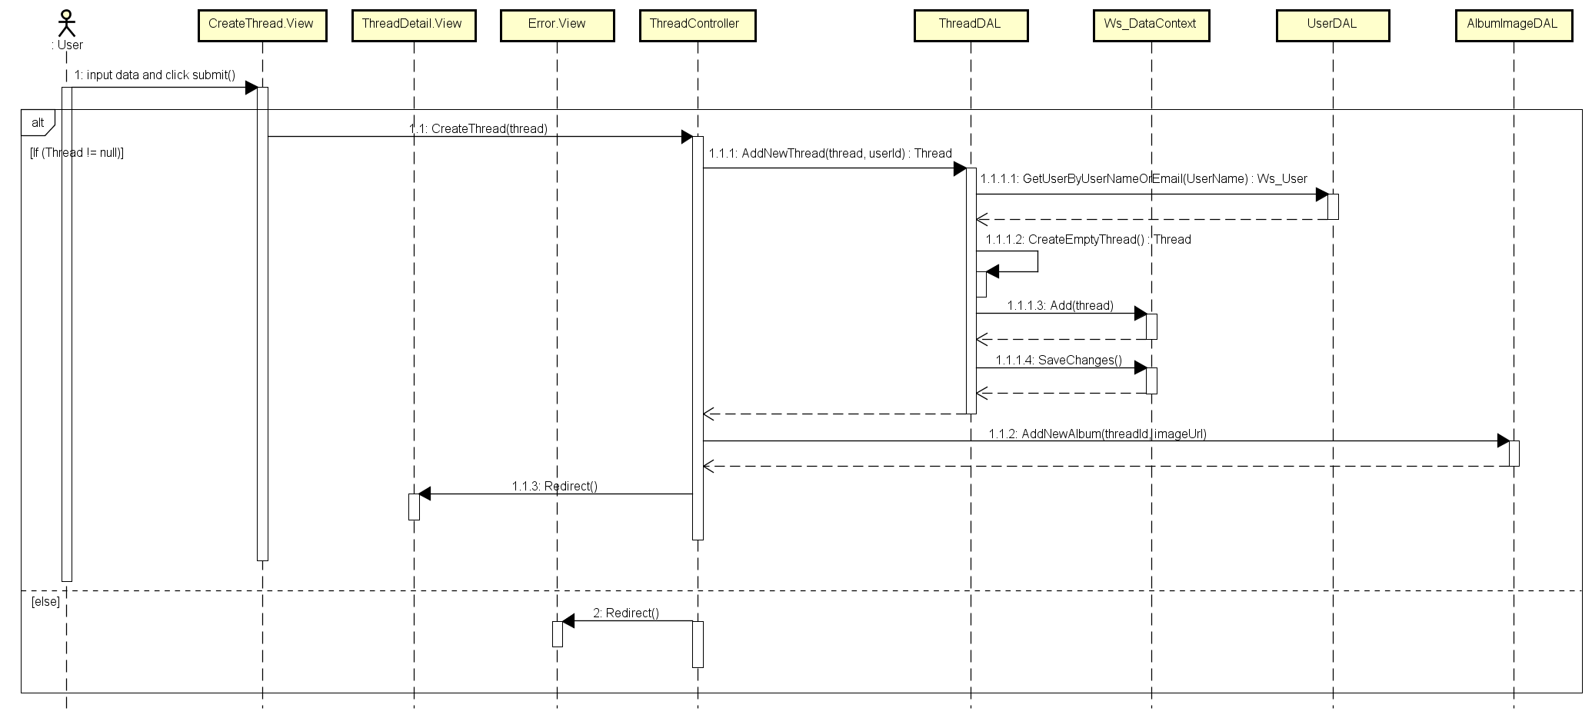

1. Create Thread Sequence Diagram

#### Edit Thread

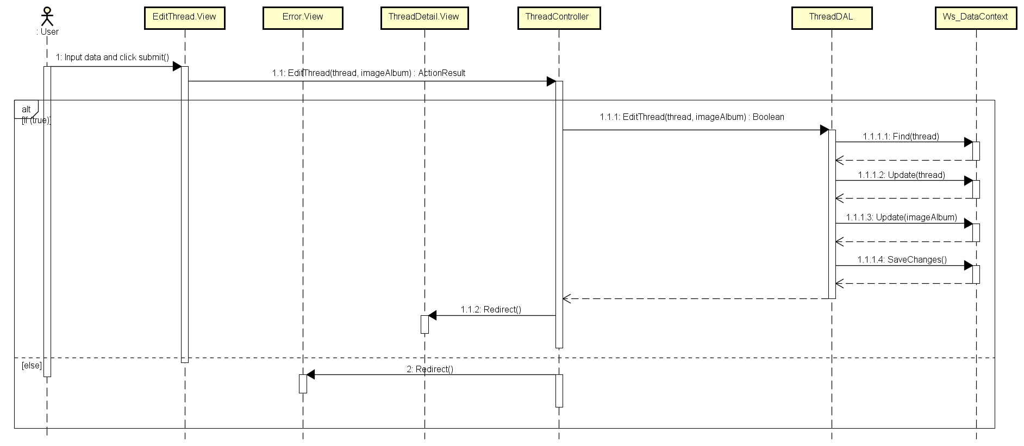

1. Edit Thread Sequence Diagram

## Organization management

### Class diagram

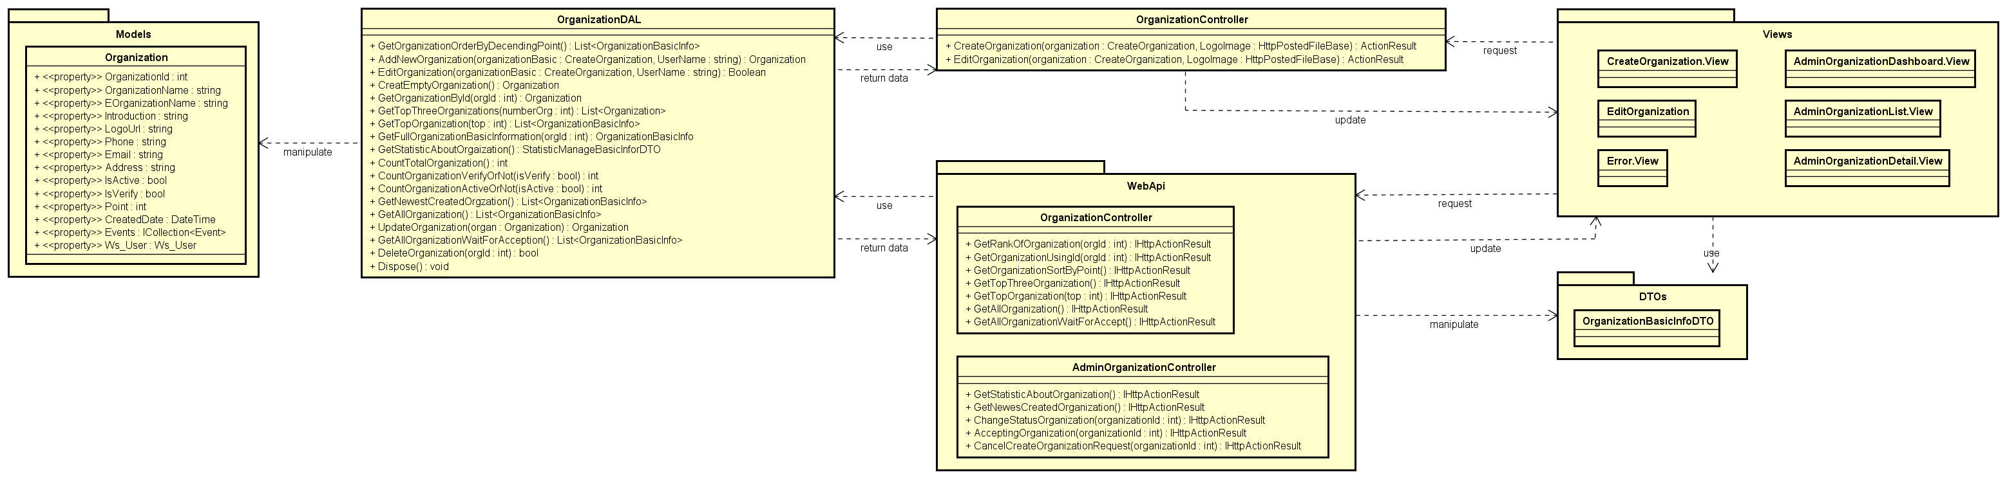

1. Organization Management Class Diagram

### Sequence diagram

#### Create organization

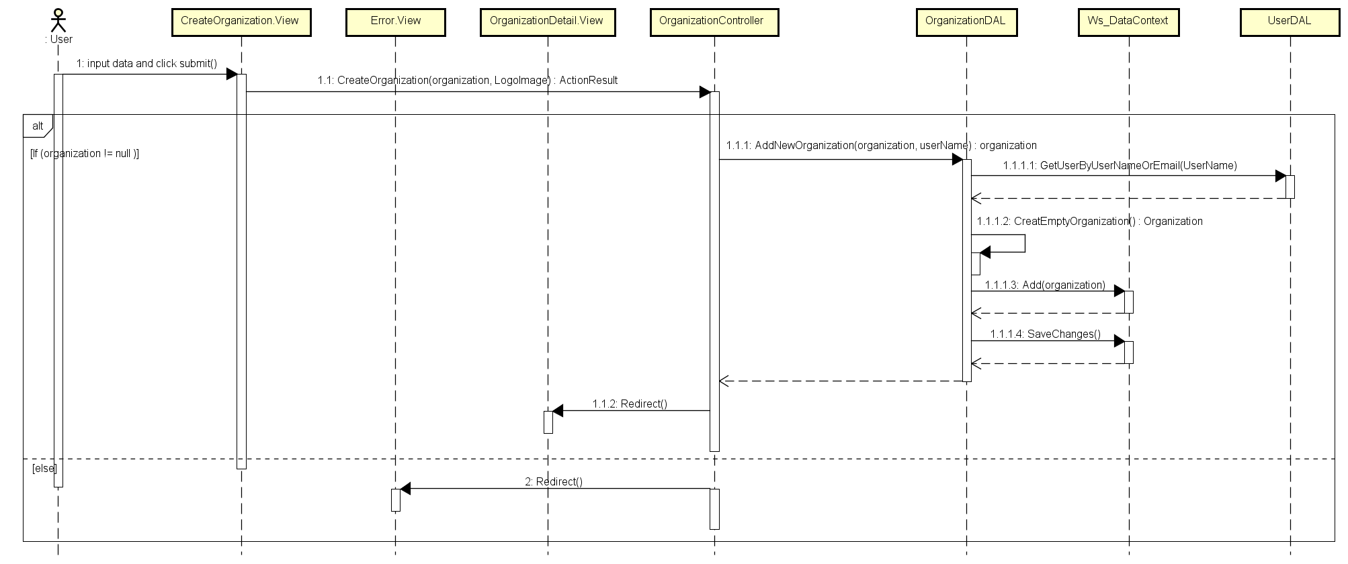

1. Create Organization Sequence Diagram

#### Edit organization

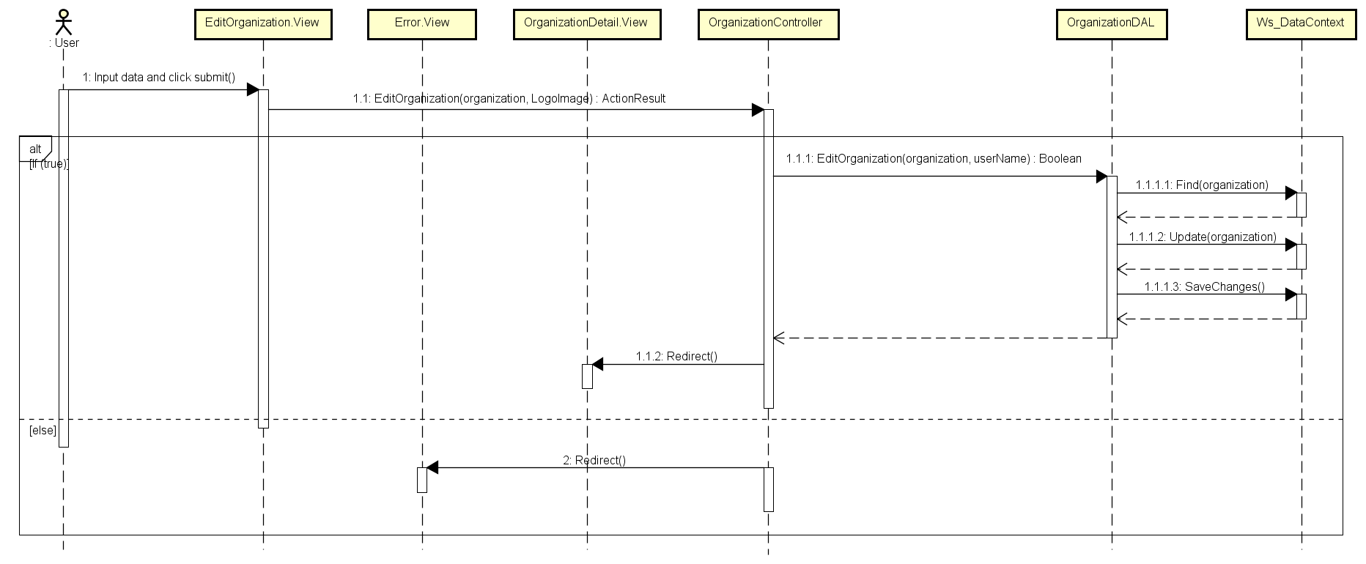

1. Edit Organization Sequence Diagram

## User information management

### Class diagram

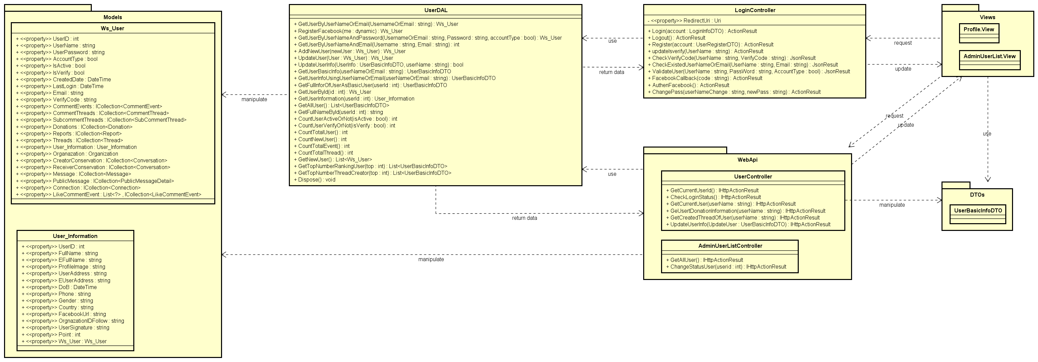

1. User information Management Class Diagram

### Sequence diagram

#### Edit profile

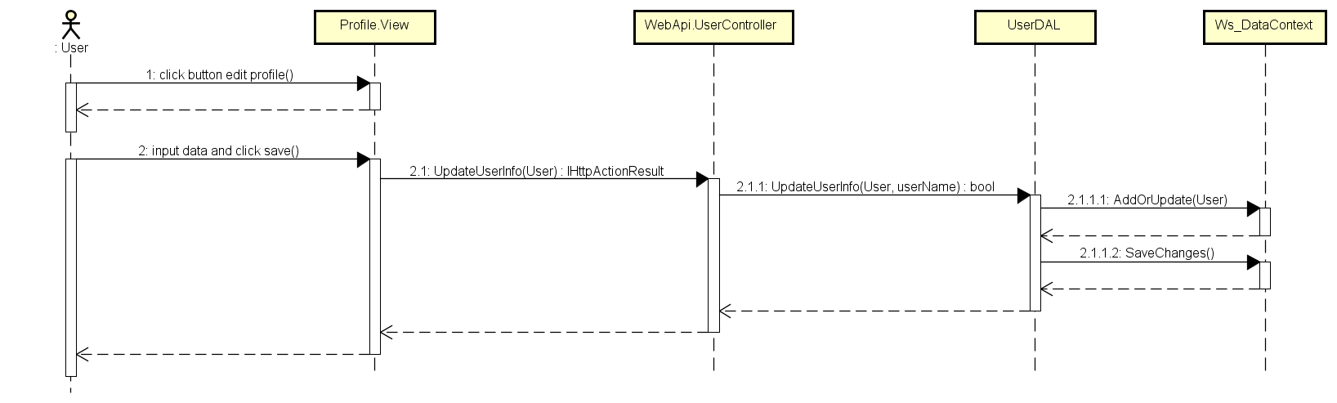

1. Edit Profile Sequence Diagram

#### Change password

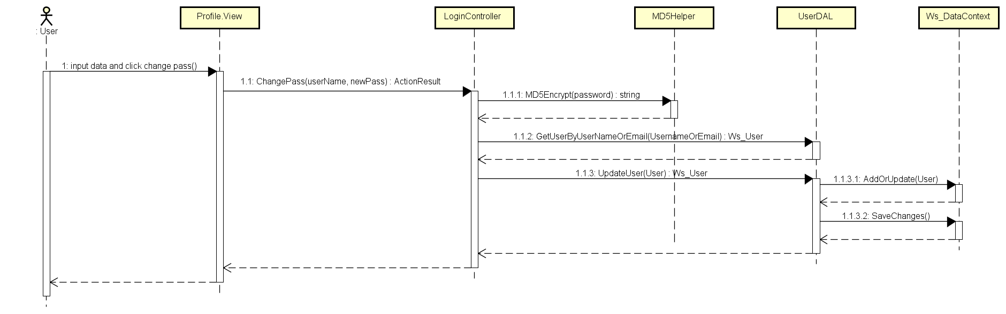

1. Change Password Sequence Diagram

#### Active/ De-active user account

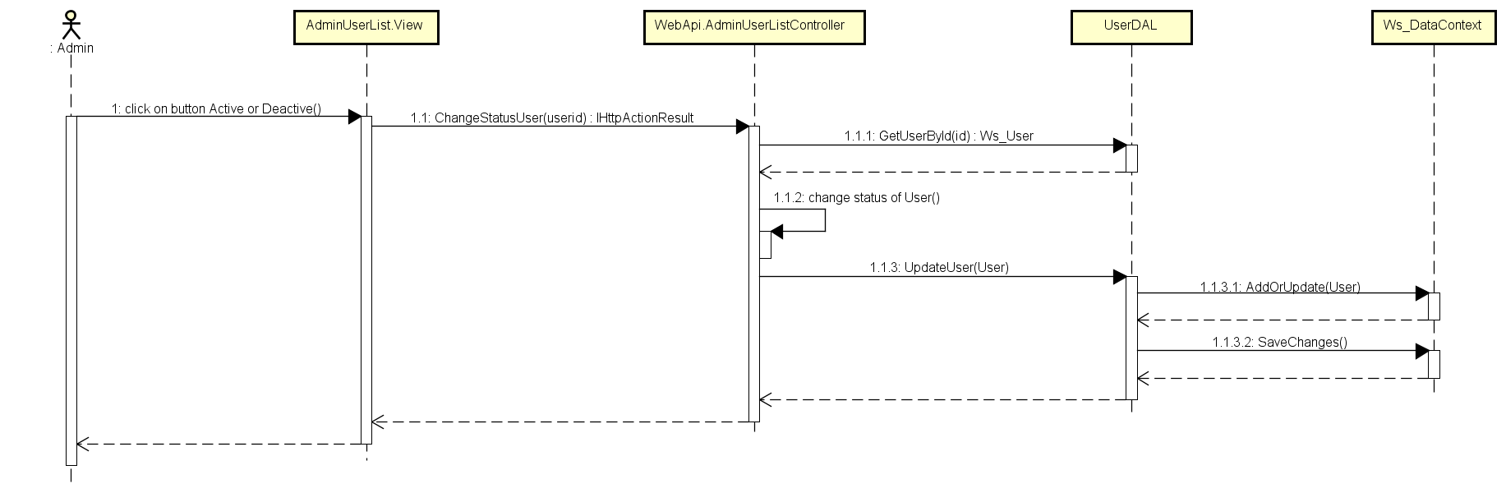

1. Active/ De-active user account Sequence Diagram

## Report management

### Class diagram

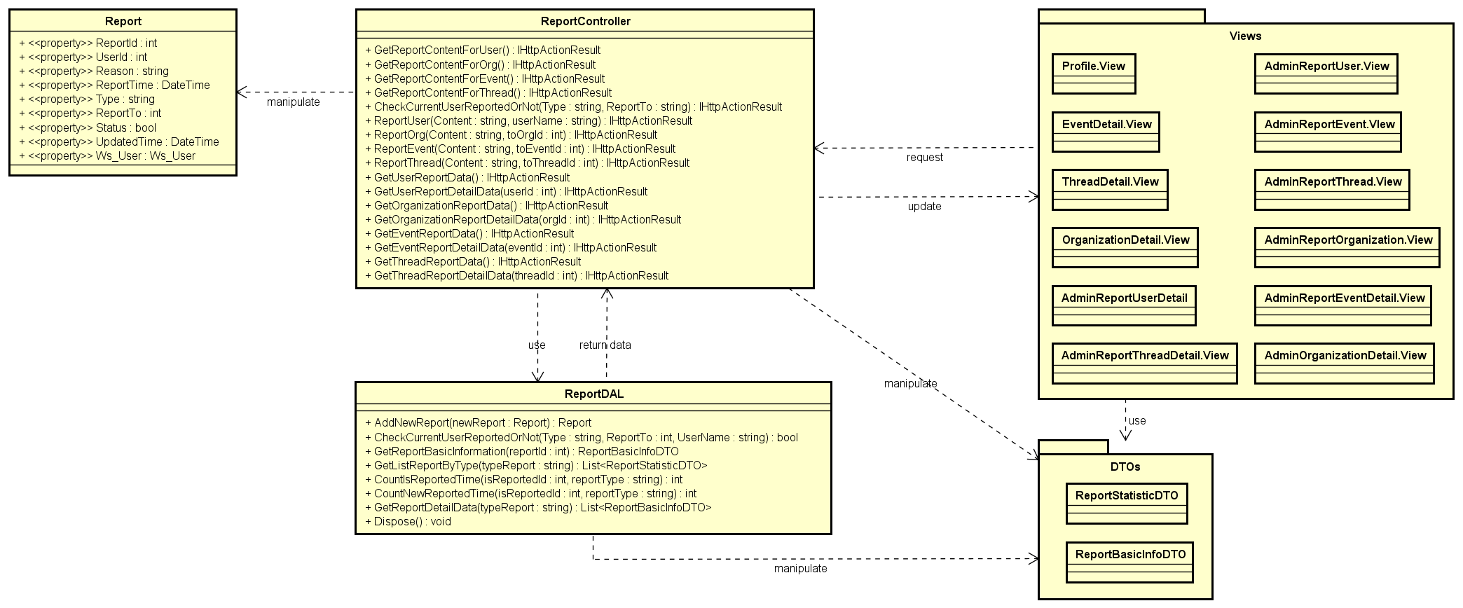

1. Report Management Class Diagram

### Sequence diagram

#### Report event

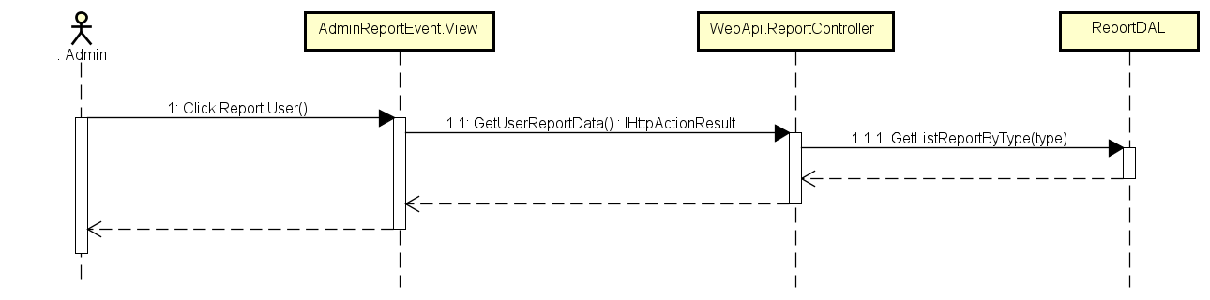

1. Load Event’s Report Sequence Diagram

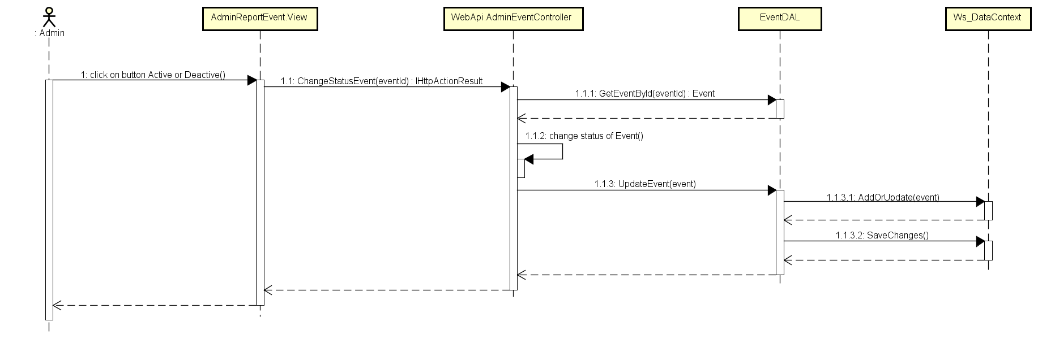

1. Change Status of Event Sequence Diagram

#### Report user

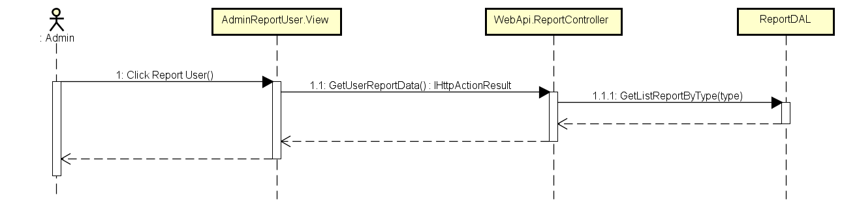

1. Load User’s Report Sequence Diagram

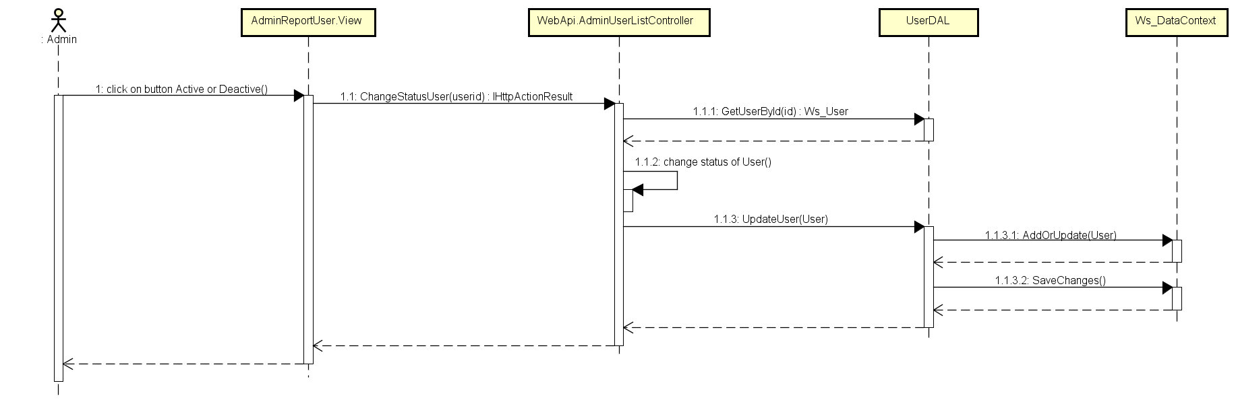

1. Change Status User Sequence Diagram

#### Report thread

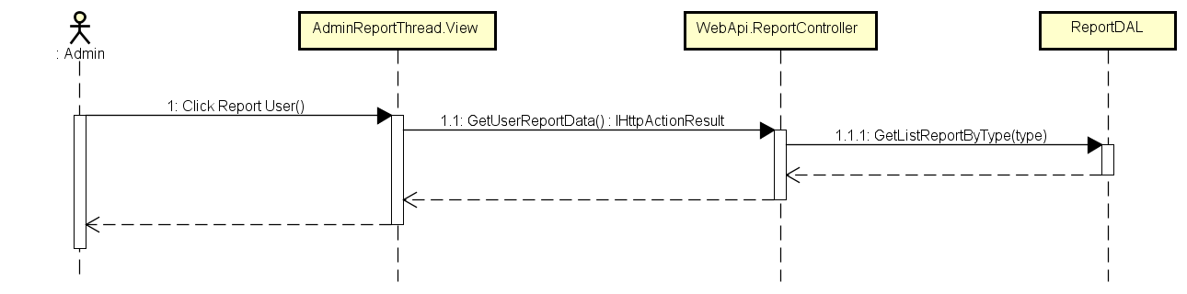

1. Load Thread’s Report Sequence Diagram

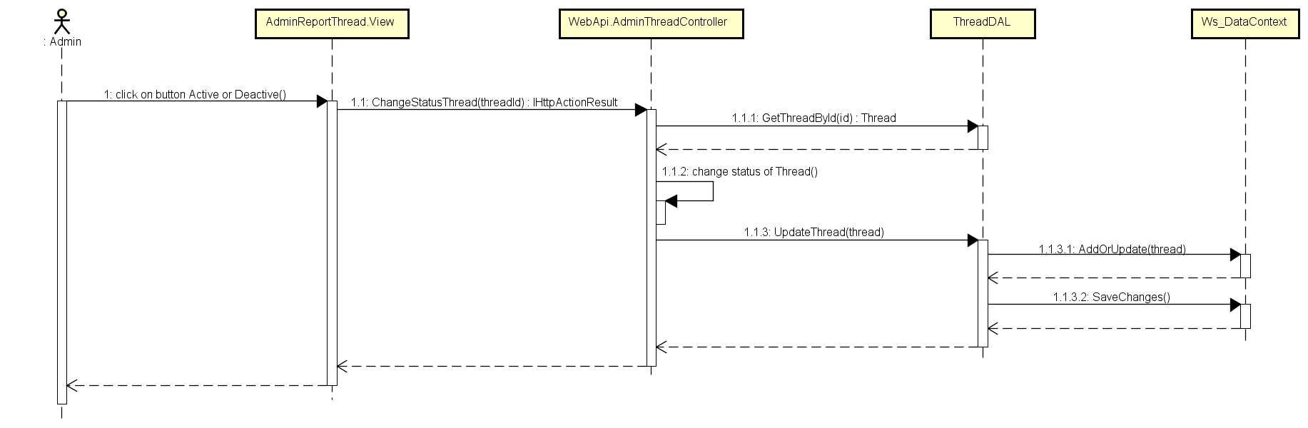

1. Change Status Thread Sequence Diagram

#### Report organization

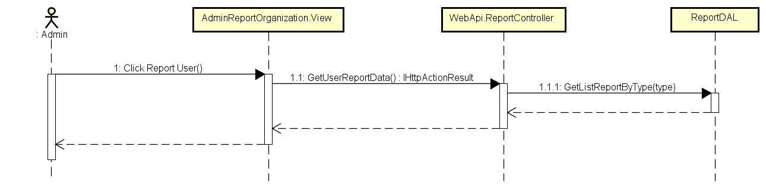

1. Load Organization’s Report Sequence Diagram

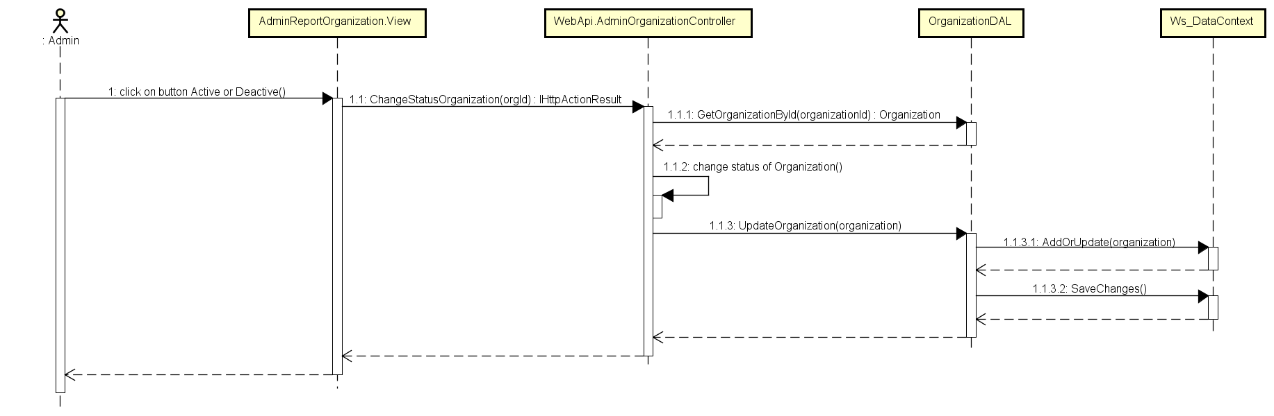

1. Change Status Organization Sequence Diagram

## Like management

### Class diagram

### Sequence diagram

#### Like/Un-like event

#### Like/Un-like comment event

#### Like/Un-like thread

#### Like/Un-like comment thread

## Message management

### Class diagram

### Sequence diagram

#### Send message

## Comment management

### Class diagram

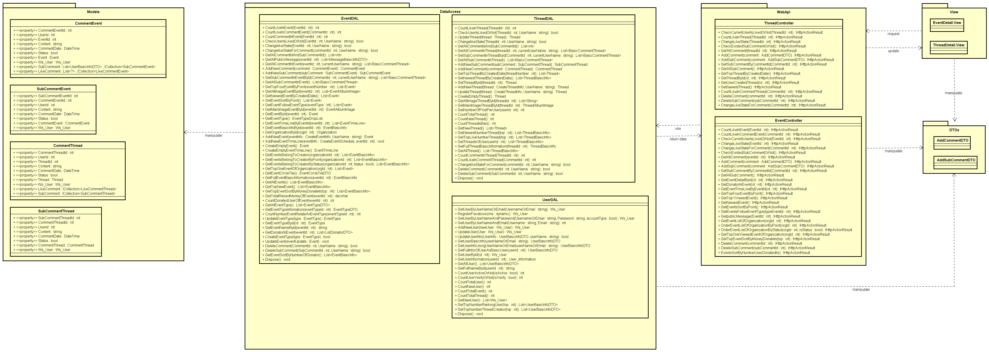

1. Comment Management Class Diagram

### Sequence diagram

#### Event Post Comment

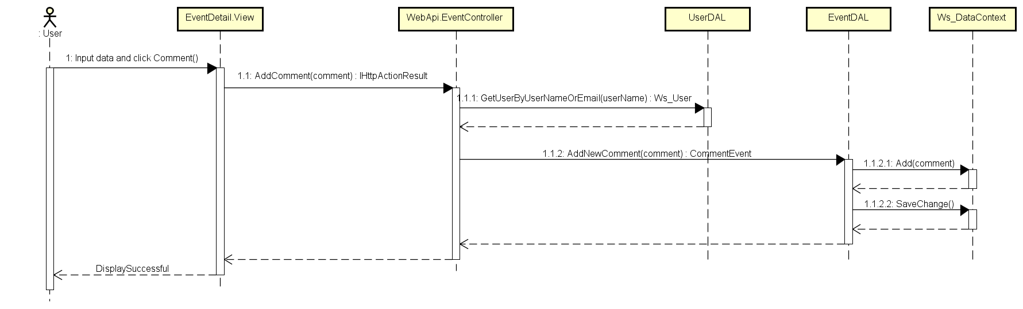

1. Event Post Comment Sequence Diagram

#### Event Reply Comment

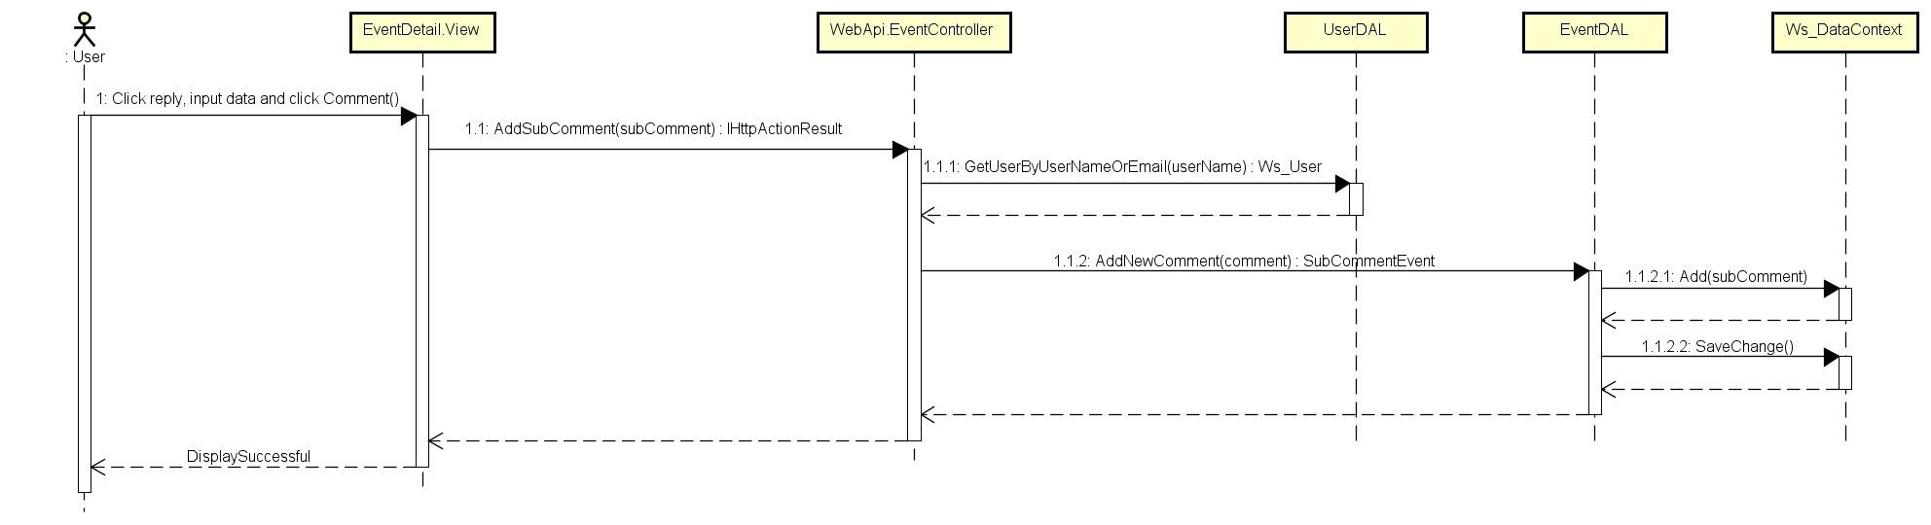

1. Event Reply Comment

#### Event Delete Comment

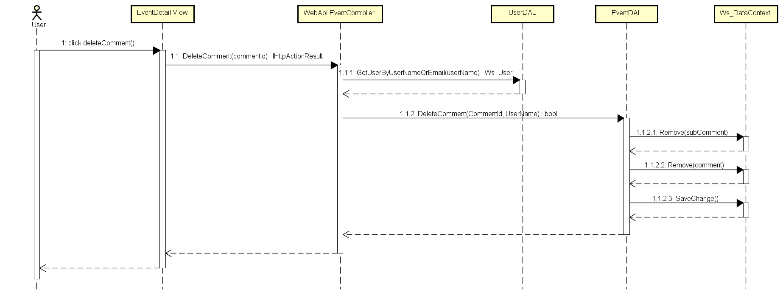

1. Event Delete Comment Sequence Diagram

#### Event Delete Reply Comment

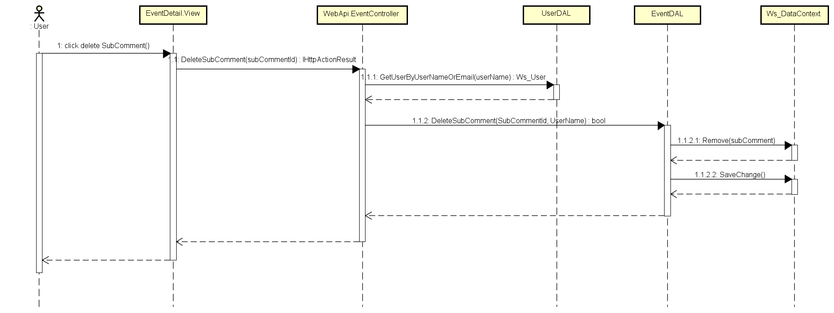

1. Event Delete Reply Comment

#### Thread Post Comment

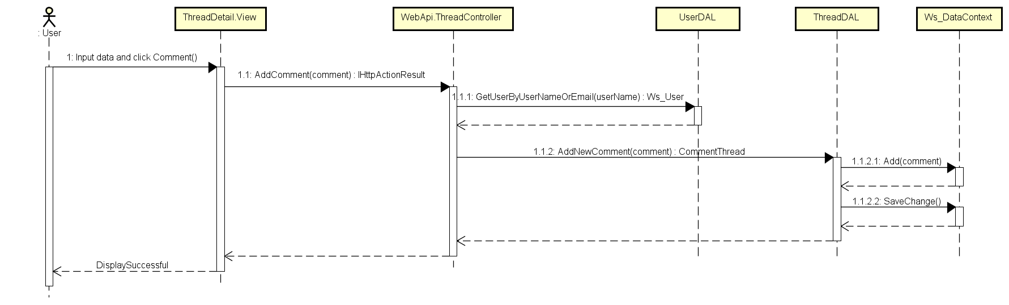

1. Thread Post Comment Sequence Diagram

#### Thread Reply Comment

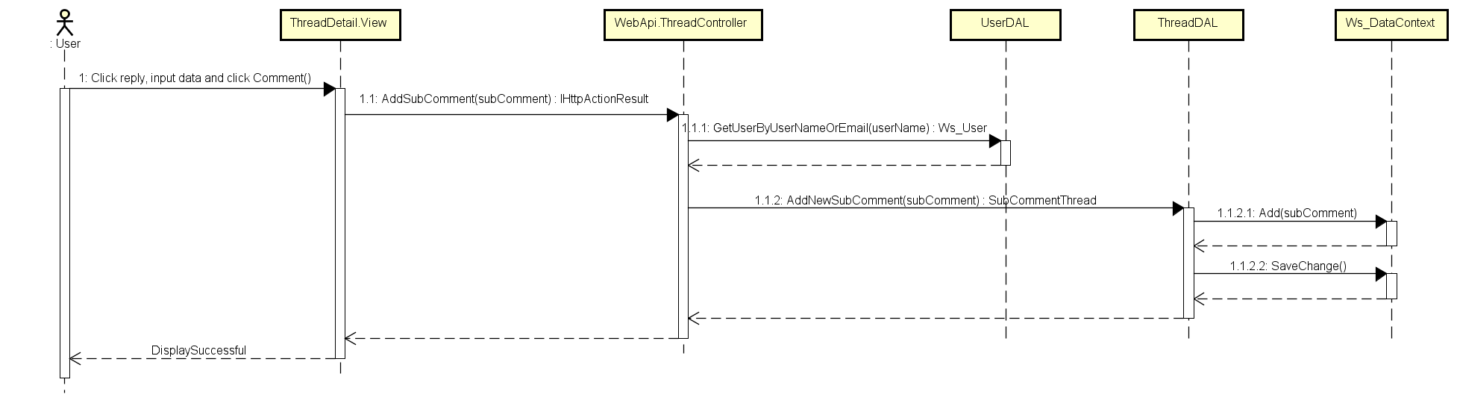

1. Thread Reply Comment Sequence Diagram

#### Thread Delete Comment

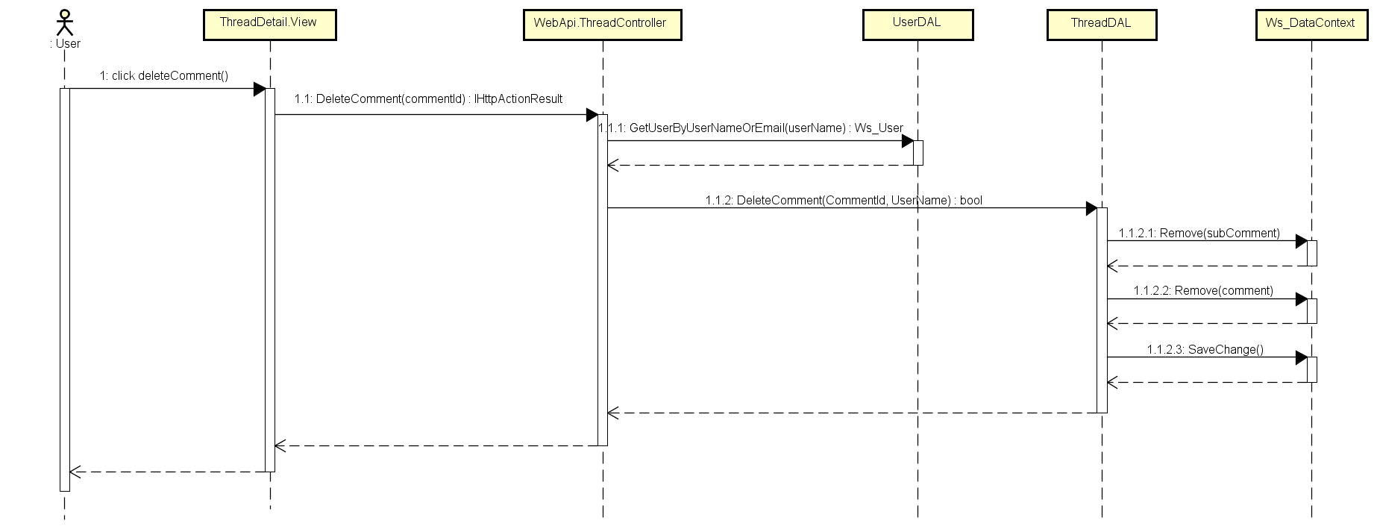

1. Thread Delete Comment Sequence Diagram

#### Thread Delete Reply Comment

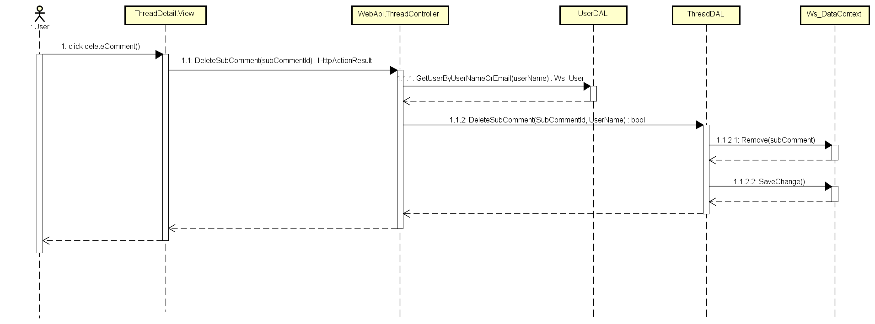

1. Thread Delete Reply Comment Sequence Diagram